HW5

Problem 5.1

a = -2; b = -2; c = -1; d = -3; e = 4; f = 0;

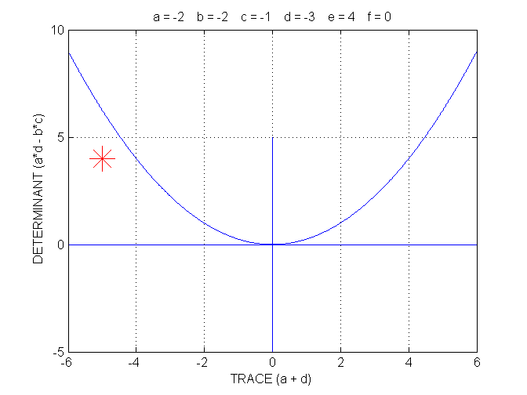

Vertical nullcline: y = – x + 2
Horizontal nullcline: y = – x/3
(T, D) = (–5, 4). The equilibrium is (3, –1) and it is a stable node.
Eigenvalues Eigenvectors Separatrices
–1 (slow) (2, –1) y = –x/2 + 1/2
–4 (fast) (1, 1) y = x – 4

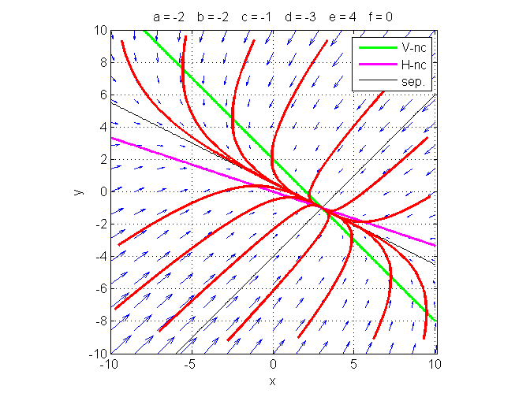

Problem 5.2

a = 1; b = 2; c = -1; d = -1; e = 0; f = 0;

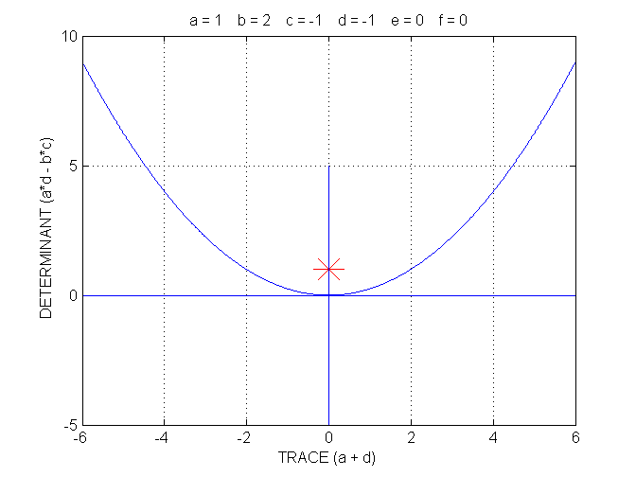

Vertical nullcline: y = – x/2
Horizontal nullcline: y = – x
(T, D) = (0, 1). The equilibrium is (0, 0) and it is a center (neutrally stable).

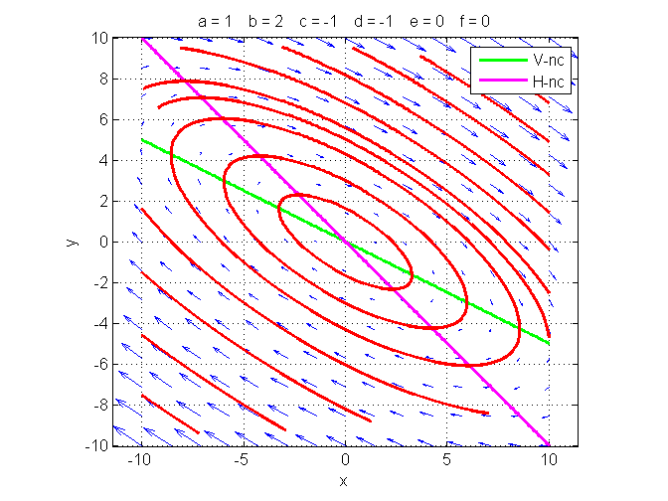
Problem 5.3

a = 3; b = 3; c = 2; d = 3; e = 0; f = 0;

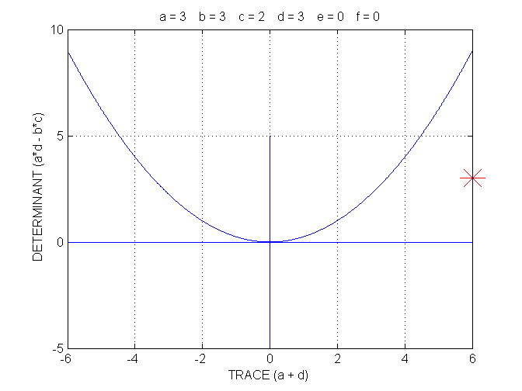

Vertical nullcline: y = – x
Horizontal nullcline: y = – 2x/3
(T, D) = (6, 3). The equilibrium is (0, 0) and it is an unstable node.
Eigenvalues Eigenvectors Separatrices
3–√6 (slow) (√6, –2) y = – √6x/3
3+√6 (fast) (√6, 2) y = √6x/3

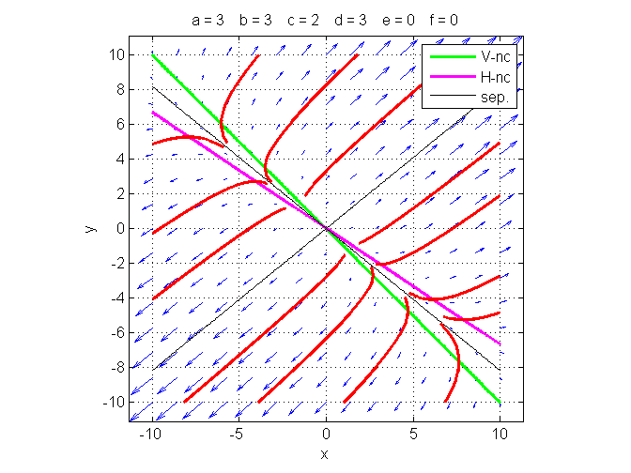

Problem 5.4

a = 4; b = -2; c = 3; d = -3; e = 4; f = 3;

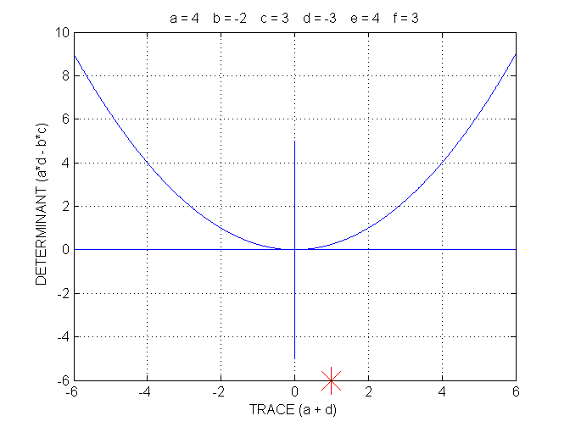

Vertical nullcline: y = 2x + 2
Horizontal nullcline: y = x + 1
(T, D) = (1, –6). The equilibrium is (–1, 0) and it is a saddle point (unstable).
Eigenvalues Eigenvectors Separatrices
3 (unstable) (2, 1) y = x/2 + 1/2
–2 (stable) (1, 3) y = 3x + 3

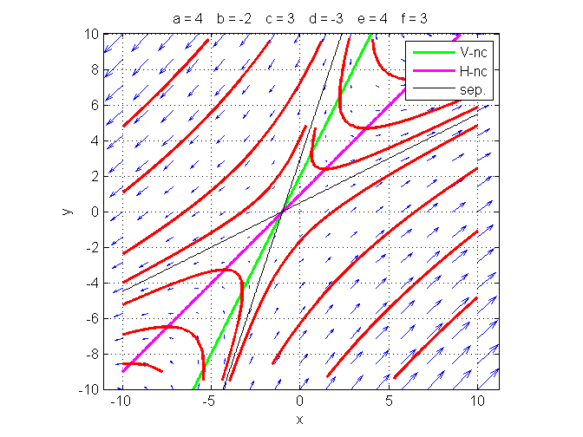

Problem 5.5

a = 0; b = 2; c = -2; d = -1; e = 0; f = 0;

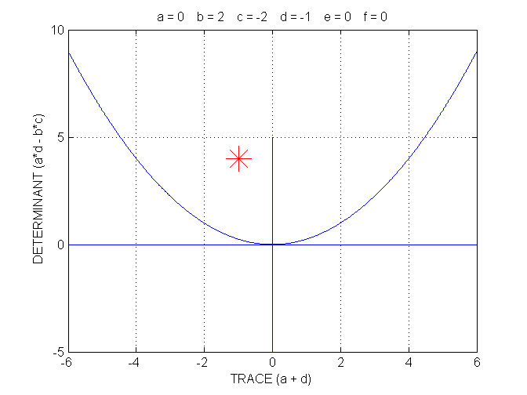

Vertical nullcline: y = 0
Horizontal nullcline: y = – 2x
(T, D) = (–1, 4). The equilibrium is (0, 0) and it is a stable spiral (spiral sink).

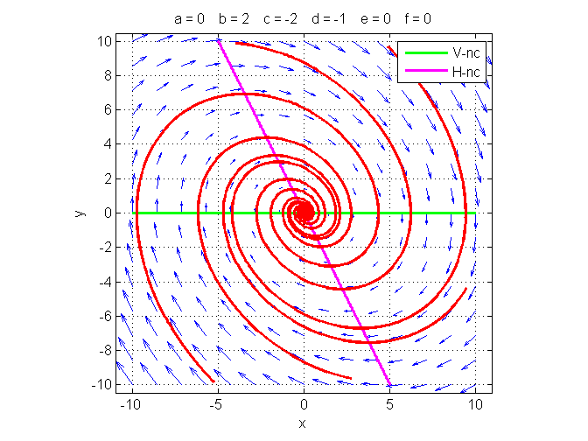

Problem 5.6

a = 2; b = 2; c = -2; d = -1; e = 2; f = 0;

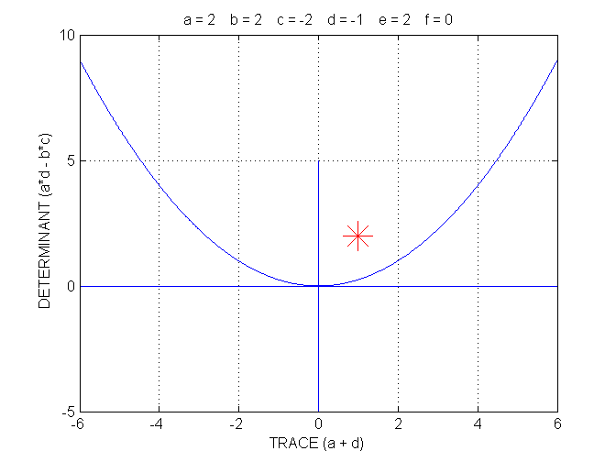

Vertical nullcline: y = – x –1
Horizontal nullcline: y = – 2x
(T, D) = (1, 2). The equilibrium is (1, –2); it is an unstable spiral (spiral source).

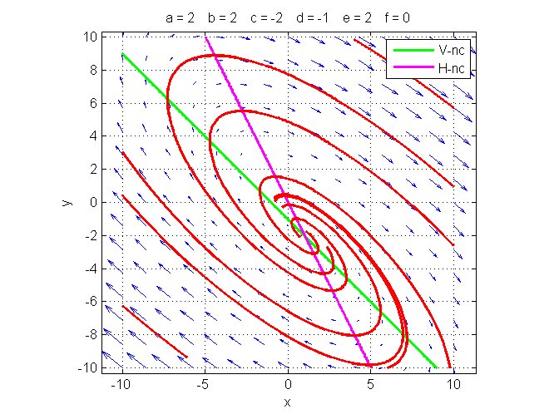

Problem 5.7

a = 0; b = 1; c = 1; d = -2; e = 2; f = 1;

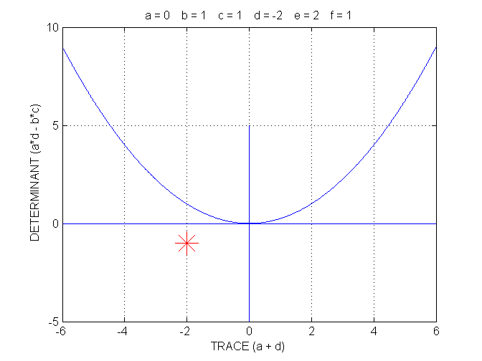

Vertical nullcline: y = – 2
Horizontal nullcline: y = x/2 + 1/2
(T, D) = (–2, –1). The equilibrium is (–5, –2) and it is a saddle point (unstable).
Eigenvalues Eigenvectors Separatrices
–1+√2 (unstable) (1, √2 – 1) y = (√2 – 1)x + 5√2 – 7
–1–√2 (stable) (1, –1–√2) y = – (√2 + 1)x – 5√2 – 7

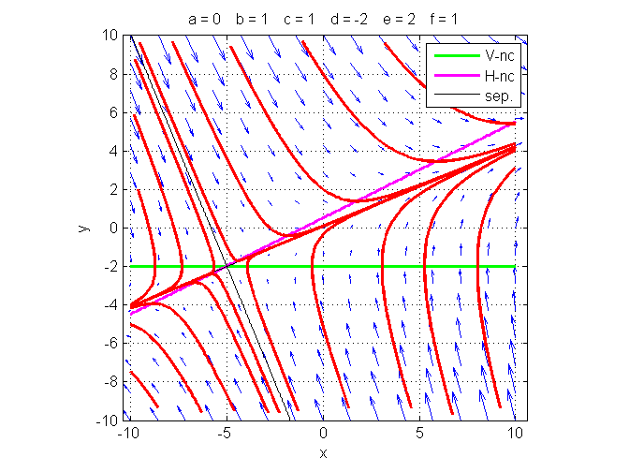

Problem 5.8

From the eigenvector-eigenvalue analysis, we obtain that the general solution is:

x(t) = k₁ exp(–4t) + 2k₂ exp(–t) + 3
y(t) = k₁ exp(–4t) – k₂ exp(–t) – 1

where k₁ and k₂ are two constants.

Given that x(0) = 15 and y(0) = 8, we solve for k₁ and k₂:

k₁ + 2k₂ + 3 = 15
k₁ – k₂ – 1 = 8

We find:

k₁ = 10 and k₂ = 1.

Thus:

x(t) = 10 exp(–4t) + 2 exp(–t) + 3
y(t) = 10 exp(–4t) – exp(–t) – 1.

For t = ln(2), exp(–t) = ½ and exp(–4t) = 1/16. Thus, at t = ln(2), we get:

x = 10/16 + 1 + 3 = 37/8 = 4.625
y = 10/16 – ½ – 1 = – 7/8 = – 0 .875.

