HW4

PART 1

Problem 4.1.

We know that the qualitative behavior of the first-order autonomous DE x' = f(x) is completely determined by the zero-crossings of f(x). Between two zero-crossings, or between – ∞ and a zero-crossing, or between a zero crossing and + ∞, the sign of f is either negative, hence x decreases, or positive, hence x increases. If x₀ is an equilibrium point and f '(x₀) > 0, f is negative to the left and positive to the right, hence x₀ is unstable; if f ' (x₀) < 0, x₀ is stable.

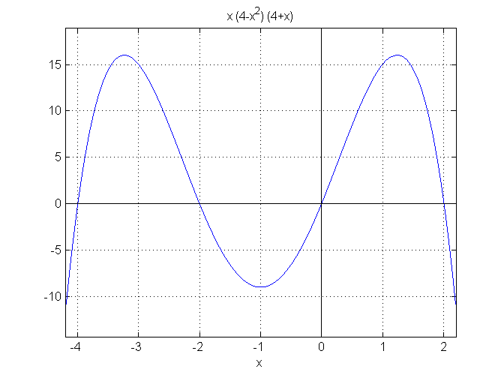
We see that there are four equilibrium points:

f '(– 4) > 0, hence – 4 is unstable

f '(– 2) < 0, hence – 2 is stable

f '(0) > 0, hence 0 is unstable

f '(2) < 0, hence 2 is stable

So we get:

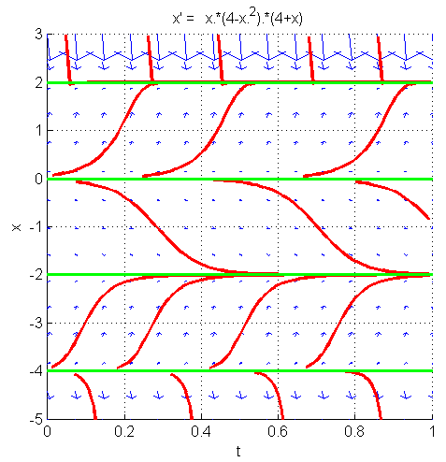

Problem 4.2.

Here, f(x) looks like this:

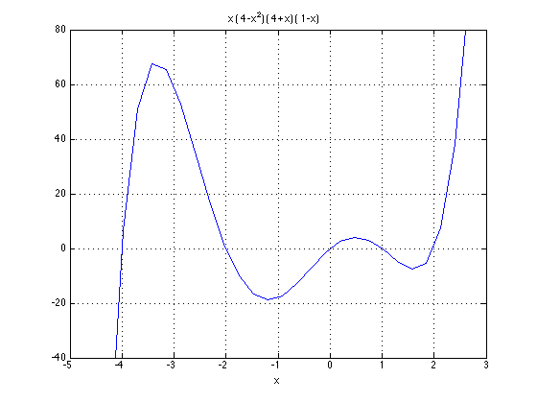
We see that there are five equilibrium points:

f '(– 4) > 0, hence – 4 is unstable

f '(– 2) < 0, hence – 2 is stable

f '(0) > 0, hence 0 is unstable

f '(1) < 0, hence 1 is stable

f '(2) > 0, hence 2 is unstable

So we get:

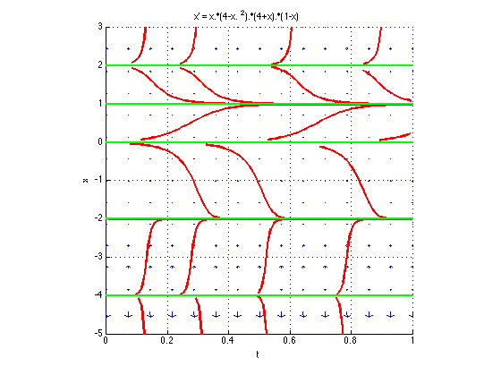

Problem 4.3.

Now f(x) looks like this:
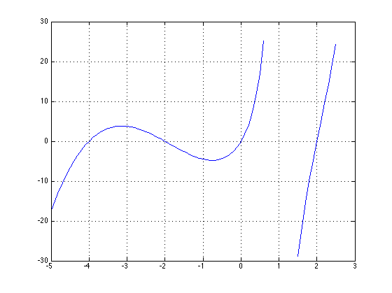

We see that there are four equilibrium points:

f '(– 4) > 0, hence – 4 is unstable

f '(– 2) < 0, hence – 2 is stable

f '(0) > 0, hence 0 is unstable

f '(2) > 0, hence 2 is unstable

There is an asymptote at x = 1: when x approaches 1 from the left, the slope of x(t) will go to +∞, which means that x will move faster and faster, and so any trajectory that starts between 0 and 1 converges to 1 in finite time, although it never actually reaches 1. The same is true when approaching 1 from the right: the slope of x(t) then goes to –∞, which means that any trajectory that starts between 1 and 2 converges in finite time to 1.

We thus get (by suitably modifying the code First-order DEs with direction field (code)
to end any trajectory that attempts to cross the line x = 1):
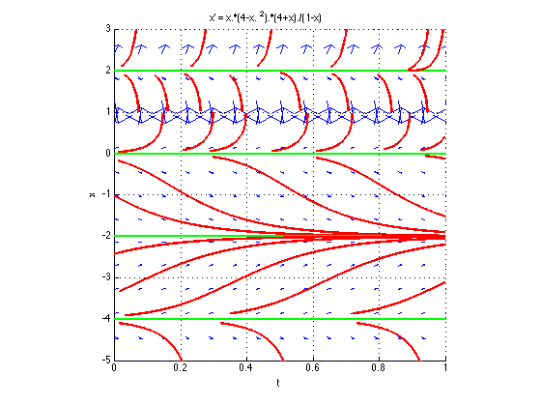

If we don’t take precautions and run the code First-order DEs with direction field (code)
without keeping trajectories from crossing the line x = 1, we get the following:

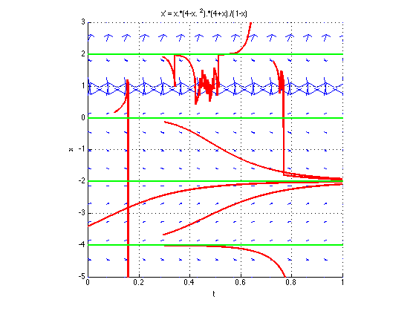

This picture is of course wrong: the Euler algorithm, which uses a fixed time increment dt, happily crosses the asymptote at x = 1. In fact, in all such cases, where f(x), the right-hand side of a DE, goes to ∞, the numerical solution computed by the Euler algorithm with a fixed dt is unstable: such a numerical solution oscillates wildly and unpredictably in the vicinity of the point x where f(x) goes to ∞.

PART 2

The code for Part 2 is in hw4.m

Problem 4.4 To get the order of magnitude of the amplitude of the current to inject into the neuron, we note that a constant current of amplitude I will result in shifting the membrane potential from its resting value V_{rest} to V_{rest}+ΔV, where ΔV = RI and R is the membrane resistance. A reasonable value for ΔV would be 20 mV, i.e., ΔV = 0.02 V. Since R = 20 MΩ, i.e., R = 2×10⁷ Ω, this yields:

I = ΔV/R = 0.02/2×10⁷ = 10^{–9}A, i.e., I = 1nA.

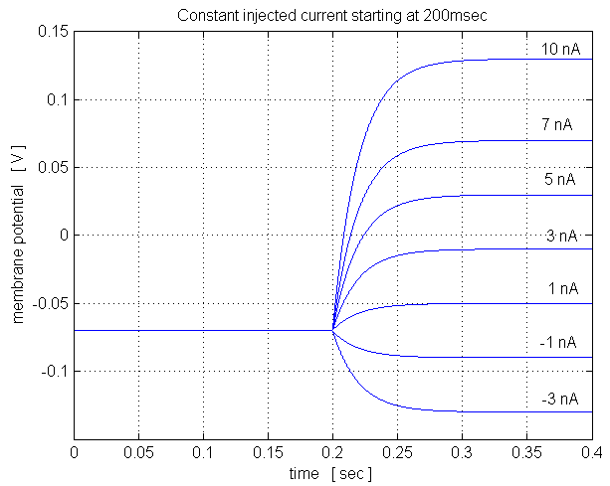
Thus, the injected current amplitude should be in the order of a few nA.

The simulations confirm that the membrane potential shift is ΔV = RI. For instance, for an amplitude of I = –1 nA, the membrane potential decreases by 20mV; for I = 10nA, the membrane potential increases by 200mV.

According to the theory, the membrane potential converges exponentially to its asymptotic value with a time constant:

τ = RC = 2×10⁷Ω×10^{–9}F = 2×10^{–2}sec = 20 msec.

This is confirmed by the plots, which show that after 100 msec, i.e., 5 time constants, V has practically reached its asymptotic value.

Problem 4.5 The following six figures show plots of the injected sinusoidal current (bottom panel) and the resulting membrane potential V (top panel) for different values of the frequency of the injected current, ranging from 1 to 1000 Hz. Note that the scale on the time axis (horizontal axis) changes from plot to plot: it always shows 5 periods of the injected current. The amplitude of the injected current is always 1 nA. All plots of V use the same scale on the V axis (from –90mV to –50mV), except for the last plot which uses higher resolution.
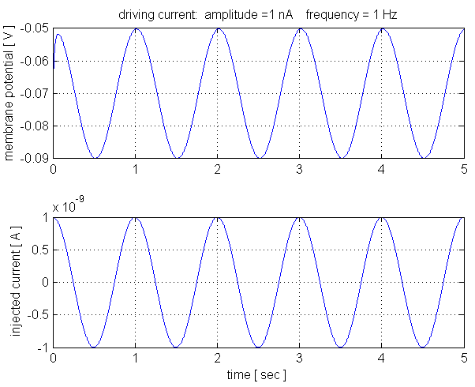

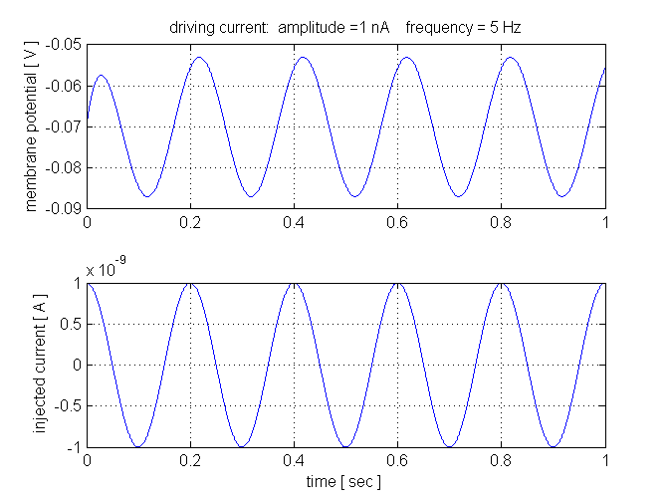

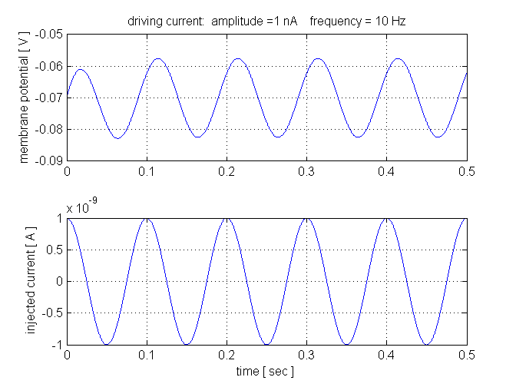

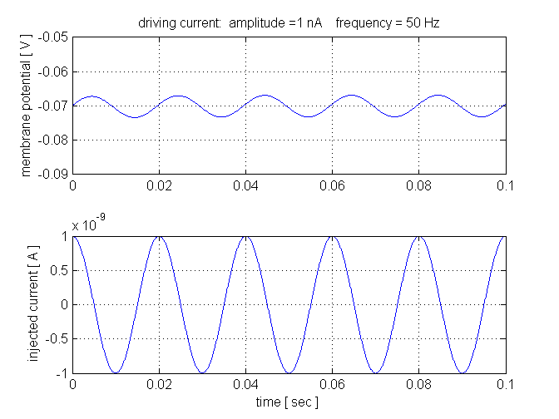

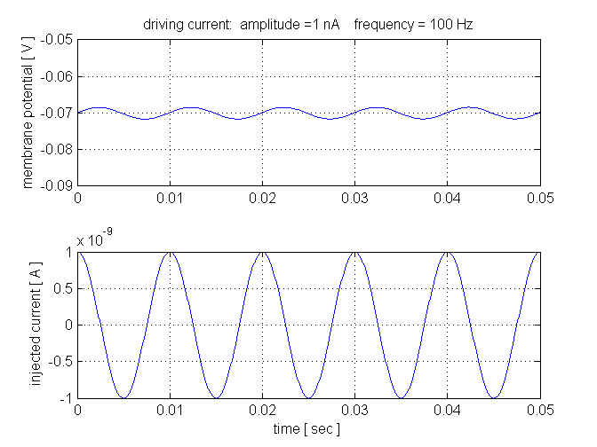

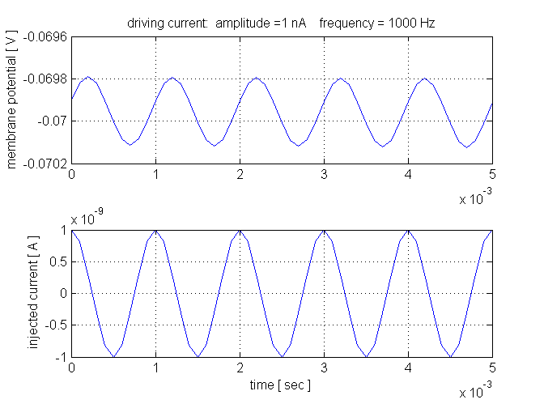

Two main observations from these six plots:

- The neuron responds with a sinusoidal membrane potential of same frequency as the driving current.

- The amplitude of the response decreases as the frequency increases.

OPTIONAL (more detailed observations)

- There is an initial period of transient behavior, of about 100 msec (corresponding again to 5 membrane time constants), in which V is not exactly sinusoidal. After this initial period is over, V exhibits perfectly sinusoidal oscillation. The mean value of the oscillatory V is exactly –.07 V, which is the equilibrium value in the absence of driving current (resting potential).
- The amplitude of the sinusoidal oscillation depends on both the amplitude of the driving current and its frequency. Thus, for a fixed value of I_amplitude, the amplitude of the oscillation of V decreases as I_frequency increases. This makes sense, since at higher frequencies the membrane capacitance absorbs a larger fraction of the oscillation of the injected current, and so the injected current is less effective in driving the neuron’s membrane potential.
- The amplitude of the sinusoidal oscillation is poportional to the amplitude of the driving current (plots not shown).
- The response of the neuron (membrane potential) is phase-shifted with respect to the driving current. The membrane potential always lags after the driving current.
- The phase lag depends on the frequency of the driving current. For low frequency (1 Hz), there is almost no phase lag. For very high frequency (1000 Hz, a case in which the amplitude of the response is very small), the phase lag is almost exactly a quarter of a period, corresponding to an angle of 90 degrees.

Further remarks:

One can actually derive an explicit formula for the phase lag as a function of the frequency of the driving current by computing the exact, i.e., analytical solution. This can be done by finding a particular solution of the non-homogeneous (and non-autonomous) equation, and adding to it the general solution of the associated homogeneous (and autonomous) equation. To find a particular solution, we guess that it is of the form

V_{PNH}(t) = B cos(2π f t – φ ),

where φ is the phase lag, and we find the parameters B and φ by plugging in this function in the equation and solving for these two parameters. The solution of the homogeneous equation is of the form C exp(– t / τ), and the last step is to find C, again by substitution.

More direct methods, from the theory of electrical RC circuits, can also be used.

