HW1
Due September 19, 2012
(6 problems)

Problem 1.1

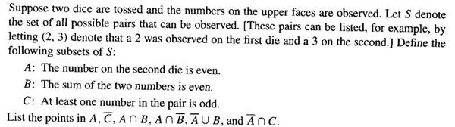

Remark: In this problem, we distinguish between the two dice. Therefore, outcome (2, 3) is not the same as outcome (3, 2).

Problem 1.2

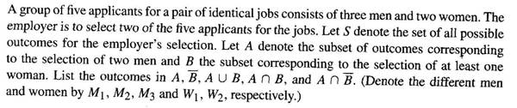

Remark: Since the jobs are said to be identical, (M1, M2) and (M2, M1) are one and the same outcome. So are (W2, M3) and (M3, W2), etc. Said otherwise, the order in choosing the applicants does not matter. As a matter of fact, the correct notation in this case is {M1, M2} (an unordered set) rather than (M1, M2) (an ordered pair). This is unlike Problem 1.1, where order did matter.

Problem 1.3

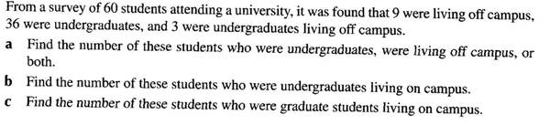

Problem 1.4

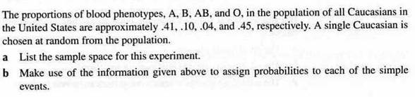

Problem 1.5

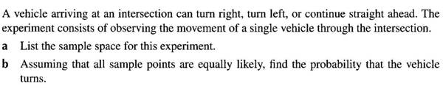

Problem 1.6
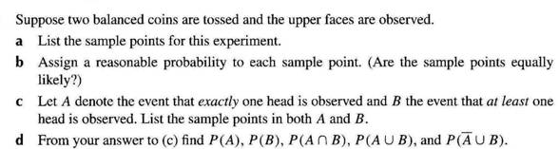

Remark: In this problem, as in Problem 1.1, order matters. Said otherwise, we distinguish between the two coins, hence HT is not the same as TH.

