**The Hopf Bifurcation**

In what follows, we consider the autonomous system of differential equations



All phase portraits in this chapter were created by [First_Order_System.m](http://www.dam.brown.edu/people/elie/am41/First_Order_System.m).

**I.** Consider first the very simple linear system given by:

*F*(*x*,*y*) = − *y*

*G*(*x*,*y*) = *x*

where ** is a positive parameter.

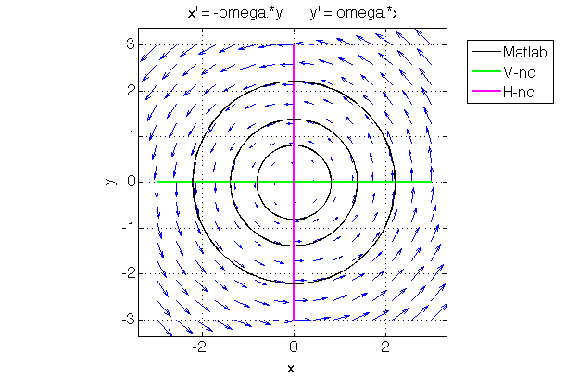The Jacobian at (0, 0) is .

Thus, *T* = 0 and *D* = **2. The eigenvalues are purely imaginary: ±*i*, and the origin is a neutrally stable center. This actually is the familiar Harmonic Oscillator. The orbits are circles, and the angular velocity is **.

It is straightforward to see that the system can be written in the equivalent polar-coordinate form:

*r’*  = 0

*’* = **,

where *x* = *r* cos(**), and *y* = *r* sin(**).

**II.** Consider now the non-linear system defined by:

*F*(*x*,*y*) = *x* − *y* − *x*(*x*2 + *y*2)

*G*(*x*,*y*) = *x* + *y* − *y*(*x*2 + *y*2).

The Jacobian at (0, 0) is . Thus, *T* = 2 and *D* = 1 + **2. The origin is a spiral source. The eigenvalues are 1 ± *i*, and the origin is a spiral source.

Here we can apply the **Poincaré-Bendixson theorem**. The Poincaré-Bendixson theorem says that if, for a given system, there is a closed and bounded domain *D* in the plane such that no trajectory leaves *D* and such that there is no stable equilibrium point in *D*, then there must be a periodic attractor, i.e., a stable, or “attracting,” limit cycle, in *D*. Although this theorem is not straightforward to prove, it is quite intuitive: since trajectories in the plane can’t cross each other, they have to eventually go either to a point attractor or to a periodic attractor.

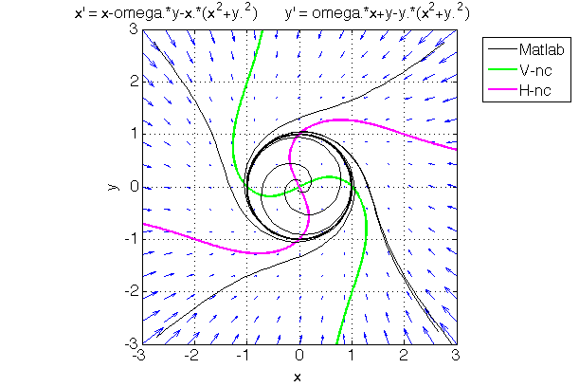To see that the conditions of the PB theorem are met for the present system, it is enough to use, for *D*, a disc of large enough radius, say *r* = 3. Clearly, all the trajectories that cross the circle *r* = 3 point inwards, because the terms in (*x*2 + *y*2) in *F* and *G* dominate.

(Alternatively, one could use the square domain −3 ≤ *x*, *y* ≤ 3 depicted in the figure.) Also, the origin is the only equilibrium point, and, as we just saw, it is unstable, Thus, by the PB theorem, there is a periodic attractor.

This system also takes a very simple form in polar coordinates:

*r’*  = *r* − *r*3

*’* = **,

which shows that the radius *r* converges to 1, while the angle * * rotates counterclockwise at constant speed.

**III.** Now consider the slightly more general system defined by

*F*(*x*,*y*) = *x* − *y* − *x*(*x*2 + *y*2)

*G*(*x*,*y*) = *x* + *y* − *y*(*x*2 + *y*2),

where ** is an additional parameter. (System II above obtains for ** = 1.)

Now the Jacobian at (0, 0) is . Thus, *T* = 2** and *D* = **2+ **2. The eigenvalues are* * ± *i*. If ** < 0, the origin is a spiral sink, while if ** > 0 (as in system **II** above, where ** = 1) the origin is a spiral source. The polar-coordinate form of the system is now:



*r’*  = *r* − *r*3 = *r*(* *− *r*2)

*’* = **,

which shows that, when ** > 0, the periodic attractor is a circle of radius √** around the origin, while if ** < 0 there is only a point attractor, the origin.

Thus, we see that as the “bifurcation parameter” * *goes from negative values to positive values, the equilibrium point (0, 0) loses its stability to the benefit of an attracting limit cycle that appears exactly at the bifurcation point. The amplitude of the periodic attractor, in this case a circle, increases with **, starting from *r* = 0 at the bifurcation. For instance, when ** = .1, the amplitude of the limit cycle is *r* = √.1 = .3162.

This type of bifurcation is called a **supercritical Hopf bifurcation**.

**IV.** Finally, consider the system defined by:

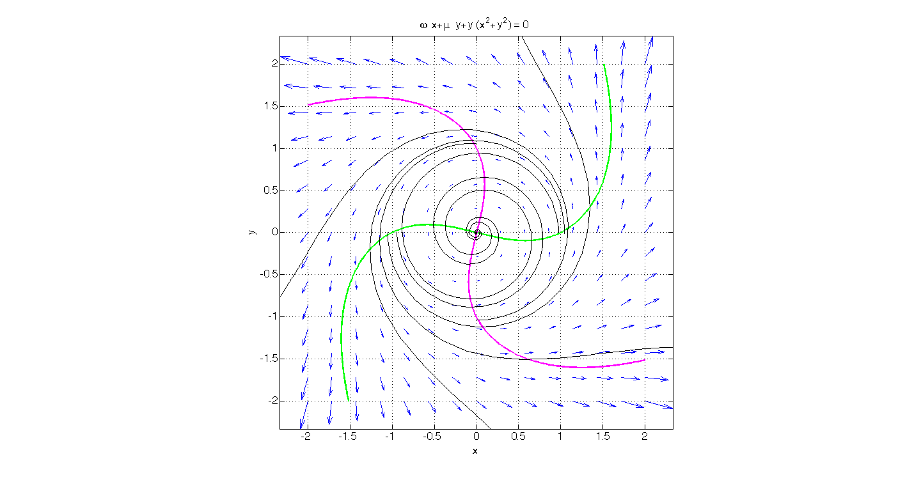

*F*(*x*,*y*) = *x* − *y* + *x*(*x*2 + *y*2)

*G*(*x*,*y*) = *x* + *y* + *y*(*x*2 + *y*2),

whose only difference with case **III** is that there is a + sign rather than a − sign in front of the non-linear terms.

The linearization of the system is identical to that of system **III**: the origin is a spiral sink for ** < 0 and a spiral source for ** > 0. However, the non-linear terms are now *de*-stabilizing. The polar-coordinate form is:

*r’*  = *r* + *r*3 = *r*(** + *r*2)

*’* = **,

which shows that, when ** < 0, there is a **repelling limit cycle**, of radius √−**. The phase portrait shown here was obtained for * *= −1, and we clearly see that there is an unstable circular orbit of radius 1. When ** > 0, the origin is unstable and any trajectory that starts at a point different from the origin goes to infinity.

This type of bifurcation, where, as the bifurcation parameter ** goes from small negative values to small positive values, the equilibrium point loses its stability through the **disappearance of a small unstable limit cycle**, is called a **subcritical Hopf bifurcation**.

In the Fitzhugh-Nagumo model, which we shall study next, periodic spiking occurs as the result of a subcritical Hopf bifurcation when the amplitude of the injected current, the bifurcation parameter, increases beyond a certain positive value.