Excitatory-Inhibitory Neural Network 2

From: Regulated Criticality in the Brain?
Elie Bienenstock and Daniel Lehmann (1999)
Advances in Complex Systems, 1, pp 361-384

Consider the system:

$\left\{\begin{matrix}\frac{\text{dx}}{\text{dt}}=−x+\text{.}5\text{tanh}(\text{ax}−\text{by}) \\ \frac{\text{dy}}{\text{dt}}=−y+\text{.}5\text{tanh}(\text{cx}−\text{dy})\end{matrix}\right.$

This system of autonomous first-order differential equations is a simplified model of the mean activities of a population of interacting excitatory (x) and inhibitory (y) neurons.

The hyperbolic tangent function tanh(x) is defined as follows:

tanh(x) = ( exp(x) – exp(–x) ) / ( exp(x) + exp(–x) )

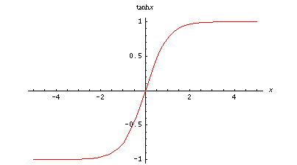

This function tanh(x) is defined for all real values of x, and it increases smoothly from –1 to 1 as x goes from – ∝ to + ∝. It has a sigmoid shape.

Note that the function is built-in in Matlab, and it is conveniently called tanh.

The derivative of tanh(x) is:

$\frac{d}{\text{dx}}\text{tanh}(x)=1{\text{/cosh}}^{2}(x)$

where cosh(x) is the hyperbolic cosine function, defined as follows:

cosh(x) = ( exp(x) + exp(–x) ) / 2.

The region of interest is:

R = {(x,y) : –0.5 ≤ x ≤ 0.5 and –0.5 ≤ y ≤ 0.5}.

In Section 1, we will examine what happens on the boundaries of region R. This will be useful wen we apply the Poincaré-Bendixson theorem.

In Section 2 we will compute the Jacobian matrix, to be used in Section 3. We will also discuss the nullclines.

In Section 3 we will do a detailed study of the system for a number of parameter settings. This will be done numerically and, to the extent possible, analytically.

In Section 4 we will draw conclusions from our study.

1. Behavior on boundaries of region r

Let us first consider the right boundary of R, i.e., x = 0.5.

We note that the function tanh is always less than 1. Therefore, when x = 0.5, the derivative of x, which is – x + .5 tanh (ax – by), is negative. The conclusion is that all trajectories that cross that right boundary are directed inward.

Similarly, using the fact that the function tanh is always larger than – 1, we see that when x = – .5 the derivative of x is positive. Hence all the trajectories that cross the left boundary of R are also directed inward.

By the same argument, the trajectories across the top and bottom boundaries of R also all point inward.

In short, all trajectories starting within R remain within R. This is one of the conditions for region R to be used in the Poincaré-Bendixson theorem.

2. Jacobian matrix and nullclines

$\frac{d}{\text{dx}}\text{tanh}(x)=1{\text{/cosh}}^{2}(x)$
Using we obtain the Jacobian matrix:

$J(x,y)=\left(\begin{matrix}−1+\frac{a}{2{\text{cosh}}^{2}(\text{ax}−\text{by})} & \frac{−b}{2{\text{cosh}}^{2}(\text{ax}−\text{by})} \\ \frac{c}{2{\text{cosh}}^{2}(\text{cx}−\text{dy})} & −1−\frac{d}{2{\text{cosh}}^{2}(\text{cx}−\text{dy})}\end{matrix}\right)$

The origin is an equilibrium point for all parameter values.

Since cosh (0) = 1, we see that the Jacobian at the origin is:

$J(0,0)=\left(\begin{matrix}−1+a/2 & {−b}/2 \\ c/2 & −1−d/2\end{matrix}\right)$

By computing the trace and the determinant of this matrix, we will be able to determine analytically the type of equilibrium at the origin, for any parameter setting of interest.

To know whether there are more equilibria, we need to examine the nullclines.

The equation of the V-nullcline is:

x = .5 tanh (ax – by), i.e., y = [ax – artanh (2x)] / b,

and the equation of the H-nullcline is:

y = .5 tanh (cx – dy), i.e., x = [dy + artanh (2y)] / c,

where artanh ("arc tangent hyperbolic") is the inverse of the function tanh.

Given the form of these equations, we will have to resort to numerical study.

In exploring the 4-dimensional parameter space, our main strategy will be to gradually increase parameter a while keeping the other three parameters constant.

We remark that parameter a affects only the V-nullcline. The slope of the V-nullcline will be of interest. This slope is given by the derivative of the function
y = [ax – artanh (2x)] / b. Noting that the derivative of artanh (x) is 1/(1 – x²), we see that the slope of the V-nullcline is: [a – 2/(1 – 4x²))] / b.

It turns out that in most cases the V-nullcline is nearly linear over much of its range, and its slope over that range is roughly equal to the slope at the origin, i.e., (a – 2)/b.

As a final remark before we turn to the study of individual parameter settings, we note that the entire system is symmetric around the origin.

Indeed, if we replace x by – x and y by – y, x' becomes –x' and y' becomes –y'. This is because tanh (–x) = – tanh (x).

This property of symmetry is true for all parameter settings.

3. Detailed study of system for various parameter settings

There are 4 parameters in the system. We will investigate various parameter settings, attempting to cover all possible qualitative behaviors of this system.

We start by setting b = 10, c = 8 and d = 2, and giving a gradually increasing values.

3.1 Parameter setting: a = 2, b = 10, c = 8, d = 2.

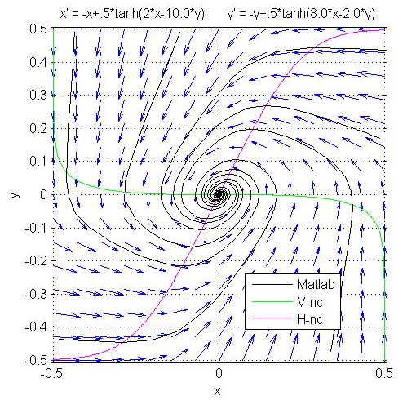

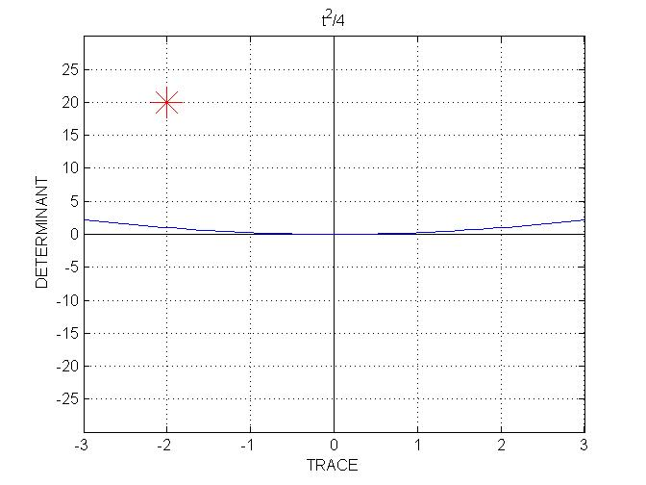

Clearly, the origin is the only equilibrium.

The slope of the V-nullcline at the origin is (a – 2)/b = 0.

The Jacobian at the origin is:
$J(0,0)=\left(\begin{matrix}0 & −5 \\ 4 & −2\end{matrix}\right)$

The trace of the Jacobian is T = – 2 and its determinant is D = 20. This places the system well within the stable spiral region.

3.2 Parameter setting: a = 7, b = 10, c = 8, d = 2.
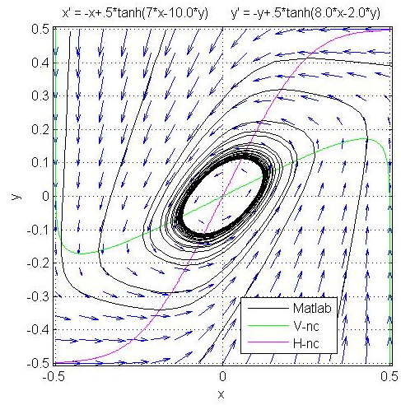

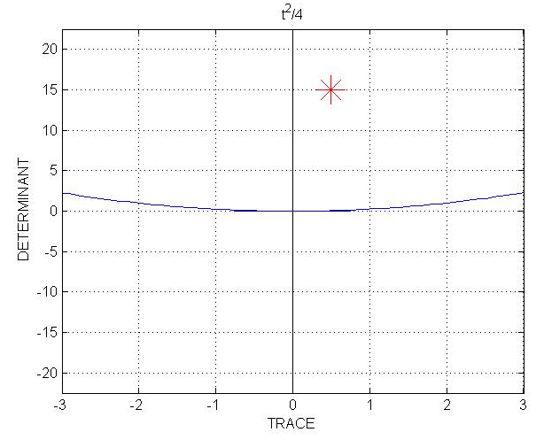

The origin is still the only equilibrium.

The slope of the V-nullcline at the origin is (a – 2)/b = 0.5.

The trajectories seem to converge to a limit cycle. In order to confirm this, we compute the Jacobian at the origin:
$J(0,0)=\left(\begin{matrix}2\text{.}5 & −5 \\ 4 & −2\end{matrix}\right)$

Hence T = 0.5 and D = 15. This places the behavior at the origin within the unstable spiral region.

Since the origin is the only equilibrium within R and it is unstable, all the conditions of the Poincaré-Bendixson theorem are met. This confirms that there is a periodic attractor in R.

Thus, as we increased parameter a from 2 to 7, the equilibrium at the origin went from a stable spiral to an unstable spiral, since we crossed the vertical line T = 0 in the T-D plane.

The bifurcation takes place at a = 6, since this is the value of a that gives T = 0. This bifurcation is of the Hopf type.

Let us examine what happens when parameter a is just a little larger than the bifurcation value 6.

3.3 Parameter setting: a = 6.1, b = 10, c = 8, d = 2.

Parameter a is just a little above the bifurcation value.
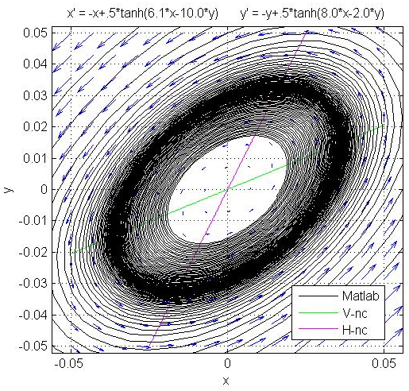

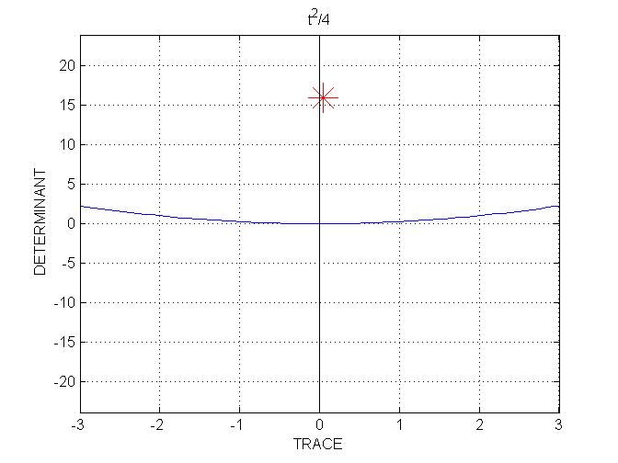

The phase portrait shows two trajectories in a small region around the unstable equilibrium (note the scale on the x and y axes).

We see that there is a limit cycle of elliptic shape. This is indicated by the dark region, where the trajectories become denser as they approach the cycle. One of the two trajectories shown is inside the cycle, and the other is outside. The cycle is near the middle of the dark region.

This limit cycle is of small amplitude: the half-axis of the ellipse is of length about .03. This is because the trace of the Jacobian is barely positive.

We now further increase parameter a.

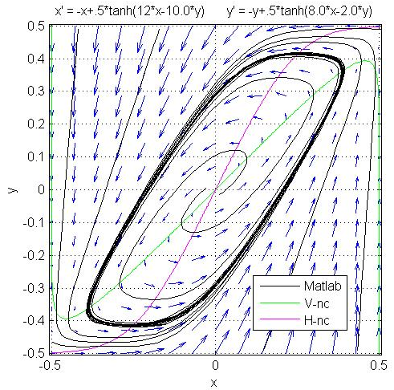
3.4 Parameter setting: a = 12, b = 10, c = 8, d = 2.

The origin still is the only equilibrium.

The slope of the V-nullcline at the origin is now (a – 2)/b = 1.

The Jacobian at the origin is
$J(0,0)=\left(\begin{matrix}5 & −5 \\ 4 & −2\end{matrix}\right)$

hence T = 3 and D = 10. We still are well within the unstable spiral region.

The Poincaré-Bendixson theorem still applies, and there still is a limit cycle.

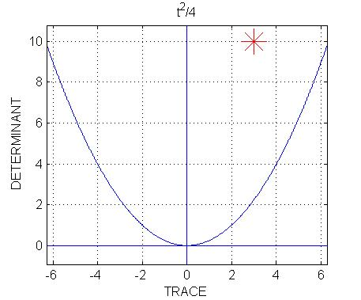
The limit cycle is now larger, and more rectangular in shape.

We note that, by gradually increasing parameter a, we increased the slope of the V-nullcline at the origin as well as over much of the interval [–.5, .5].

Given the shape of the H-nullcline, which remains fixed because we keep c and d constant, we should expect that if we further increase parameter a the two nullclines will eventually intersect each other near the top-right and bottom-left corners of the square.

This situation is examined next.

3.5 Parameter setting: a = 15, b = 10, c = 8, d = 2.
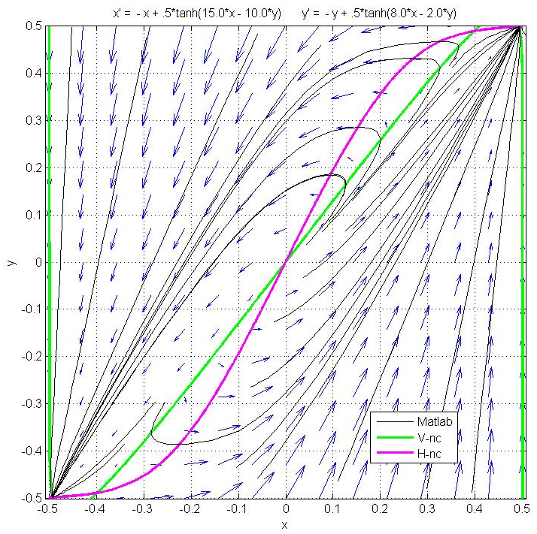

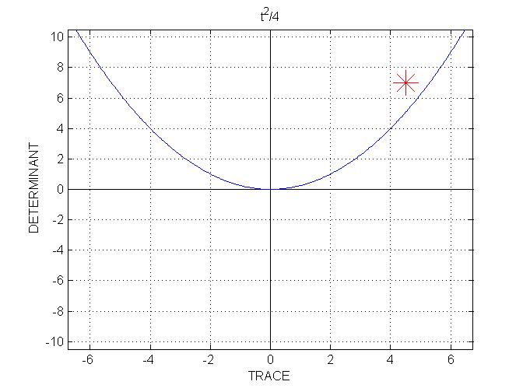

The slope of the V-nullcline at the origin and over most of the range is (a – 2)/b = 1.3. This is large enough that the two nullclines intersect near the corners.

As a result, there are now 5 equilibrium points.

The Jacobian at the origin is
$J(0,0)=\left(\begin{matrix}6\text{.}5 & −5 \\ 4 & −2\end{matrix}\right)$

hence T = 4.5 and D = 7. The origin is still within the unstable spiral region.

There are two intersection points near the upper right corner. Since the system is exactly symmetric, there also are two intersection points near the bottom left corner.

We see that only one in each pair of equilibria, the one closest to the corner, is stable.

Thus, out of the 5 equilibria in R, two are stable. Hence the Poincaré-Bendixson theorem does not predict the existence of a limit cycle.

Indeed there is no limit cycle in this case. Instead, the two stable equilibria, near the corners of R, attract all the points in R (except unstable equilibria and points on separatrices).
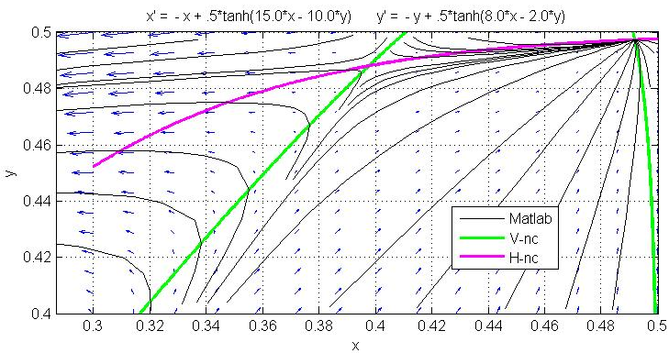
To elucidate the nature of the stable and unstable equilibria, we examine the phase portrait in the upper right corner at higher resolution:

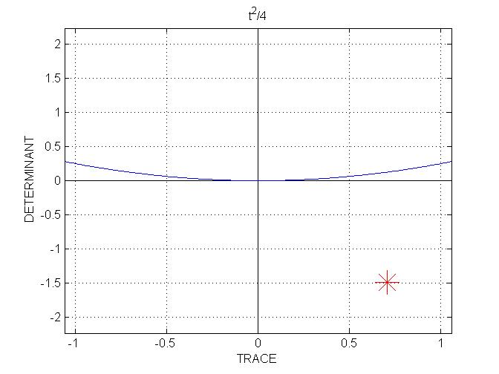

From inspection of the phase portrait, the unstable equilibrium seems to be of saddle-point type, and this is is confirmed by the T-D analysis.

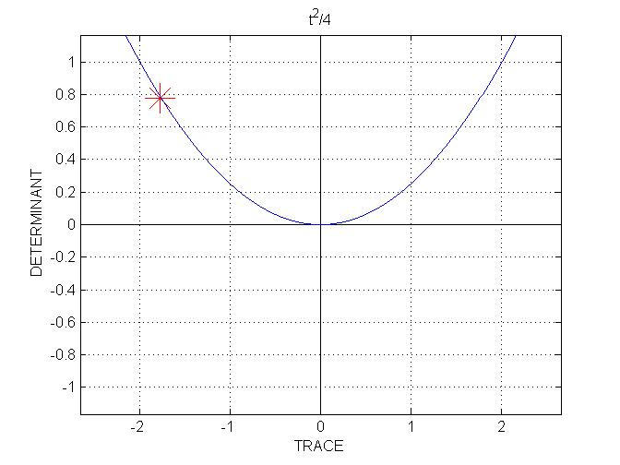
The stable equilibrium seems to be of node type.
The T-D analysis indicates a star node, but we can't know for sure. The (T, D) point could actually be slightly to the left of the parabola, in which case we have a regular node; or it could be exactly on the parabola, giving a star node, at least for the linearized system; or it could be slightly to the right of the parabola, giving a spiral point. This cannot be determined analytically, because the position of the equilibrium is known only approximately, from the nullcline plot. But it is a purely theoretical issue. In practice, the spiraling around the attractor, if present, is too tenuous to be seen. The main point is that the equilibrium is well within the region of stability, i.e., far from both axes T = 0 and D = 0.

Using a trial-and error method, one can find that the bifurcation value for a is, approximately, 14.22.

The following shows what happens just before the bifurcation.

3.6 Parameter setting: a = 14.215, b = 10, c = 8, d = 2.

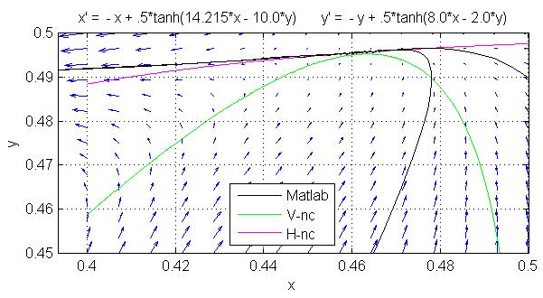

For this value of a, the nullclines are almost touching, but not quite. As a result, there still is a limit cycle, and this is the only attractor in R. The above diagram is a blow-up of the upper-right corner, showing a single trajectory. This trajectory starts at (0.5, 0.49), passes very close to the point of almost contact of the nullclines, and then effects a large loop before coming again from below, being then indistinguishable from the very large limit cycle.

The following shows what happens just after the bifurcation.

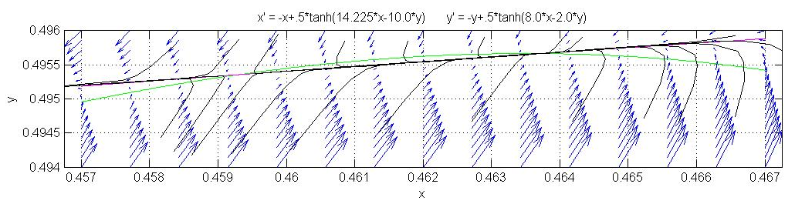
3.7 Parameter setting: a = 14.225, b = 10, c = 8, d = 2.
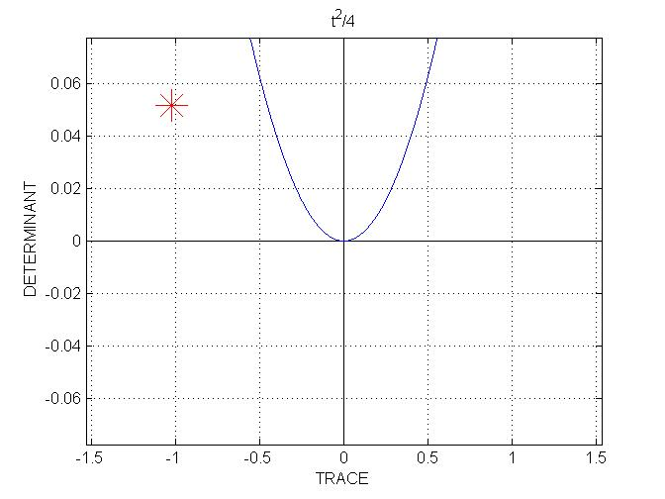

The stable equilibrium, which, from examining the nullcline diagram, is approximately (0.4636, 0.4957), is a node.

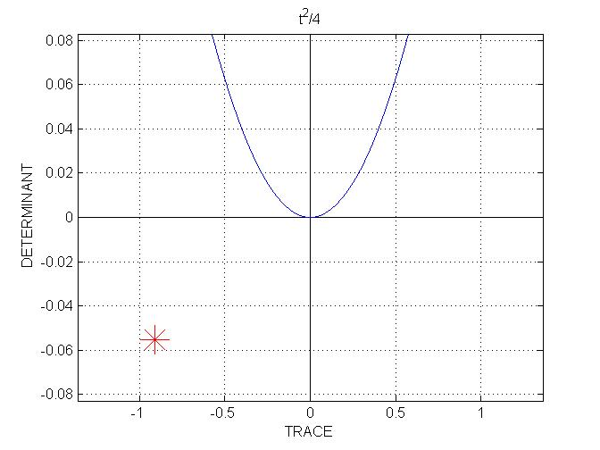

The unstable equilibrium, which is approximately (0.4593, 0.4954), is a saddle point.

We see that these two equilibria, the node and the saddle point, are quite close to the line D = 0 in the (T, D) plane, and are located, roughly, symmetrically with respect to this line.

We conclude that this bifurcation is of saddle-node type.

To sum up so far, we were able to describe three qualitatively distinct types of behavior of our system. These occur for different values of parameter a, the other three parameters being kept constant at b = 10, c = 8, and d = 2.

The three different types of behavior are:

- for a < 6, single point attractor, a spiral sink, at the origin;
- for 6 < a < 14.22, single periodic attractor, the origin being a spiral source;
- for 14.22 < a, two attracting nodes, two saddle points, and a spiral source at the origin.

Can we get qualitatively different behaviors for different settings of the other three parameters?

The answer is yes:

3.8 Parameter setting: a = 5, b = 2, c = 2, d = 5.
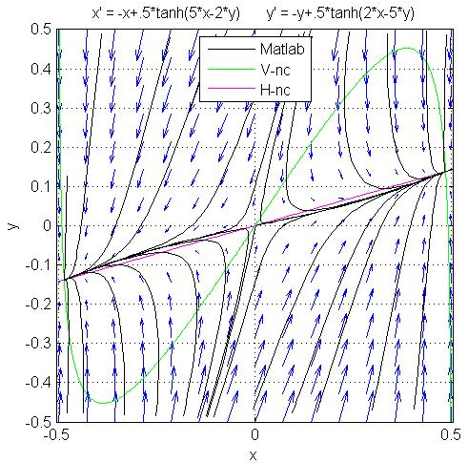

In this situation there are only three equilibria. The origin is a saddle point, and the other two equilibria are stable nodes.
We end our study with a parameter setting that yields a rather unexpected behavior, one that becomes apparent only after careful scrutiny.

3.9 Parameter setting: a = 9, b = 10, c = 2.75, d = 2.
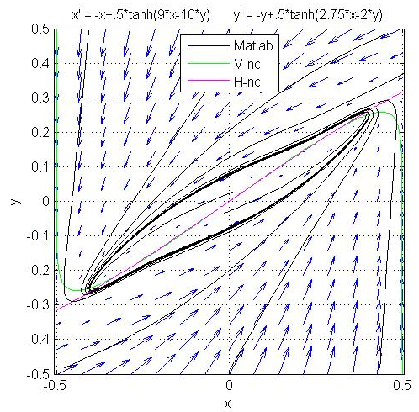

The phase portrait seems at first unremarkable: There is a rather large, counterclockwise, limit cycle, of the type observed before.

However, we notice that the two nullclines follow each other very closely as x ranges over the interval [– .4, .4].

This situation deserves more scrutiny: Could it be that the nullclines intersect each other more than once?

A careful examination shows that this is indeed the case.
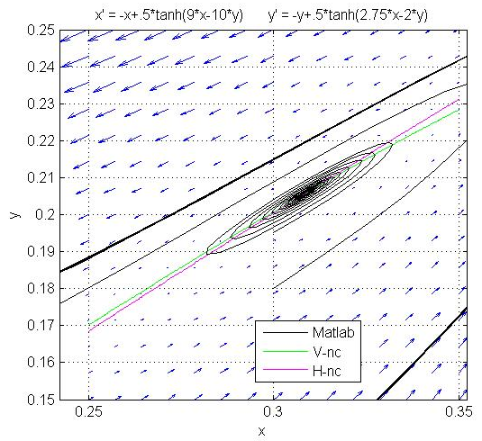

As shown in the high-resolution diagram, the nullclines intersect at, approximately, (0.31, 0.205). (Because of the symmetry of the system, the nullclines also intersect at (– 0.31, – 0.205).)

Two trajectories are shown.

One trajectory starts at (0.3, 0.18). It is next seen going downward and leftward through the point (0.3, 0.21). It ends up very near the limit cycle, generating a thick trace there.

The other trajectory starts at (0.3, 0.195). It does not converge to the limit cycle. Rather, it converges to the equilibrium point near (0.31, 0.205). This equilibrium thus turns out to be a spiral sink.
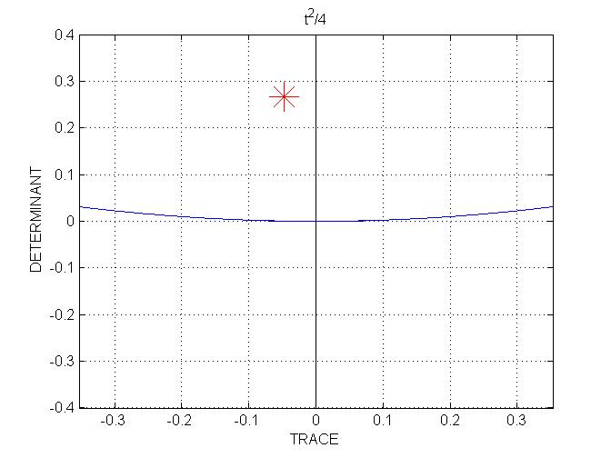

That this equilibrium, whose existence we did not see at all on the full-scale phase portrait, is a spiral sink is confirmed by the T-D analysis, displayed to the right.

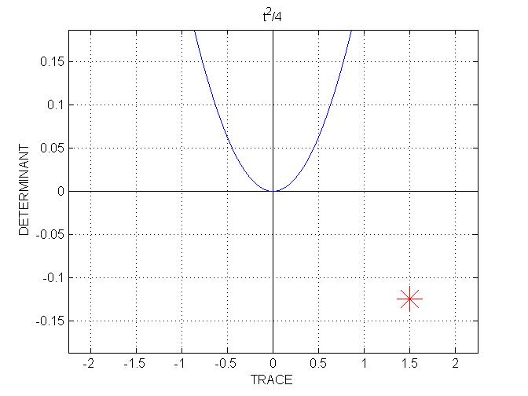
The Jacobian at the origin is
$J(0,0)=\left(\begin{matrix}−1+a/2 & {−b}/2 \\ c/2 & −1−d/2\end{matrix}\right)=\left(\begin{matrix}3\text{.}5 & −5 \\ 1\text{.}\text{375} & −2\end{matrix}\right)$

yielding T = 1.5 and D = – 0.125.

The origin is thus a saddle point.

We conclude that, in this parameter setting, there are three attractors: one large limit cycle and two spiral sinks inside the attracting limit cycle.

Note that in this case the existence of a periodic attractor could not be predicted from the Poincaré-Bendixson theorem, since there are point attractors in R.

4 Concluding remarks

This rather simple system of two coupled first-order autonomous differential equations exhibits a variety of behaviors, depending on parameter values.

The three main behaviors are:

- Single point attractor in the center of R. This corresponds to an intermediate level of steady-state activity for both neuron populations, excitatory and inhibitory.

- One point attractor near the top-right corner of R and one point attractor near the bottom-left corner. These point attractors correspond, respectively, to a state of high-activity for both populations of neurons and to a state of low-activity for both populations.

- One large counterclockwise limit cycle, correponding to strong periodic oscillation of the two populations, the excitatory population leading.

Of interest are the bifurcation points of the system. When the system is close to a bifurcation, a small perturbation may cause the system to switch from one type of behavior to a very different type of behavior.

A perturbation can be either a small change in the parameters (as demonstrated in the study), or it can be brought about by an external input of small amplitude, which can be modeled as a non-autonomous term (not shown in this study).

In particular, when the system is close to the saddle-node bifurcation, a small perturbation may cause a dramatic change of behavior.

Might there be mechanisms in the central nervous system that would systematically bring the parameters governing its dynamics close to bifurcation? Such mechanisms could be of value to the brain, as they might allow it to be exquisitely sensitive to small external inputs.

Such mechanisms have indeed been proposed. See Regulated Criticality in the Brain? for such a mechanism related to Hebbian plasticity and based on the system studied here.

