Excitatory-Inhibitory Neural Network 1

From:
Theoretical Neuroscience, by Peter Dayan and Larry Abbott, MIT Press, 2005
pp. 266-269

The system studied here is one the simplest types of neural networks to exhibit oscillatory activity. It can be regarded as a simplified model of a fully-connected network comprised of a large number of excitatory and inhibitory neurons. Alternatively, it can be regarded as a model comprised of a single excitatory neuron and a single inhibitory neuron.

All synaptic weights of a given type are given identical values: the excitatory-to-excitatory, inhibitory-to-excitatory, excitatory-to-inhibitory, and inhibitory-to-inhibitory weights are, respectively 1.25, –1, 1, and 0. (These are dimensionless parameters.)

Similarly, all firing thresholds of a given type are identical: the excitatory and inhibitory thresholds are, respectively, –10 Hz and 10 Hz.

Finally, all time constants of a given type are identical: the excitatory and inhibitory time constants are, respectively, 10 ms and τ_{I}. The system has a single parameter: τ_{I}.

The excitatory and inhibitory firing rates are denoted, respectively, v_{E} and v_{I}. The system then reads:

10v_{E}' = – v_{E} + [1.25v_{E} – v_{I} + 10]₊

τ_{I}v_{I}' = – v_{I} + [ v_{E} – 10]₊

The function [x]₊ denotes the positive part of x:

[x]₊ = x if x > 0
[x]₊ = 0 if x ≤ 0

Note that the use of the positive-part function makes the system non-linear, and indeed it is the only nonlinearity in the system.

With a single parameter, the system exhibits a limited range of behaviors. Of interest is the bifurcation from a stable-equilibrium behavior (attracting spiral point) to a limit-cycle (periodic attractor) behavior, which occurs when τ_{I} becomes larger than 40 ms.

T = 0.25/10 – 1/τ_{I}
D = 0.75/10τ_{I}

With parameter τ_{I} = 20:
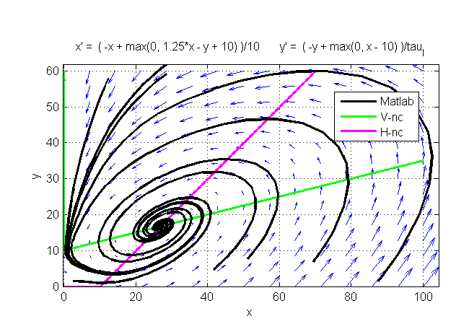

With parameter τ_{I} = 60:
