A separable DE is a DE of the form

dx/dt = f(x, t)

where f(x, t) = g(x)h(t). Thus:

dx/dt = g(x)h(t).

Such a DE can often be solved very easily by separation of variables, i.e., rewriting it

dx/g(x) = h(t)dt

and integrating each side.
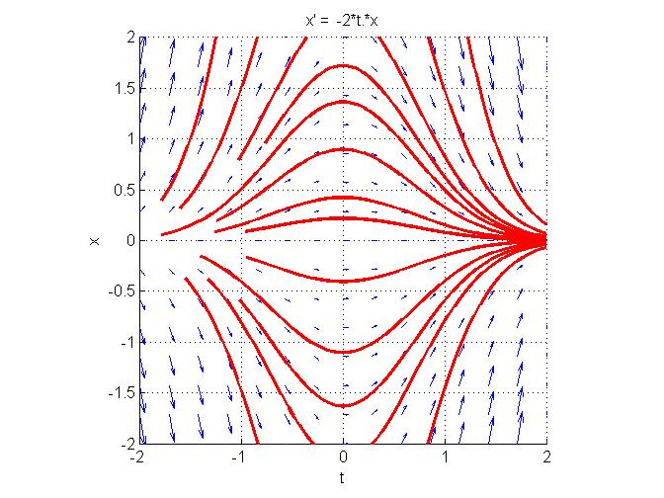
For instance, the DE

dx/dt = −2tx

yields

dx/x = −2tdt,

hence, by integration,

ln |x| = −t² + C,

or:
x = C' exp(−t²).

The trajectories are bell-shaped.

The isoclines (not drawn) are the curves of equation xt = k for various values of k; these are hyperbolas.

