Non-Linear Systems
of Autonomous First-Order DEs

$$\left\{\begin{matrix}\frac{\text{dx}}{\text{dt}}=F(x,y) \\ \frac{\text{dy}}{\text{dt}}=G(x,y)\end{matrix}\right.$$

Linearization
1. Compute the Jacobian, $J(x,y)=\left(\begin{matrix}\frac{∂F}{∂x}(x,y) & \frac{∂F}{∂y}(x,y) \\ \frac{∂G}{∂x}(x,y) & \frac{∂G}{∂y}(x,y)\end{matrix}\right)$.

2. For every equilibrium point (x₀, y₀), evaluate the 2-by 2 matrix A = J(x₀, y₀).

3. In most cases, the behavior of the nonlinear system around (x₀, y₀) is qualitatively the same as that of the linearized system, hence determined by the usual eigenvalue-eigenvector analysis of A. In particular, the type of equilibrium at (x₀, y₀) is determined by the position of (Trace(A), Determinant(A)) in the (T, D) plane.

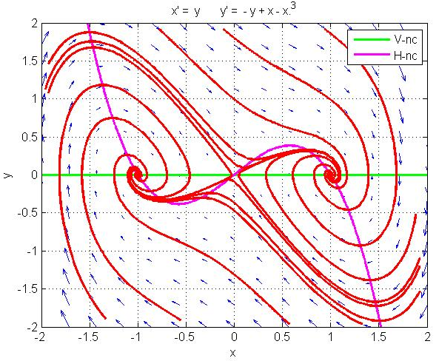
Example

F = y
G = − y + x − x³

Linearized system has

- Saddle at (0, 0)
- Spiral sink at (−1, 0)
- Spiral sink at (+1, 0)

and so does the nonlinear system.
When does linearization apply?

Only equilibrium points of generic type are guaranteed to transfer automatically from the linearized system to the non-linear system. An equilibrium is generic if it does not belong to one of the special cases that sit on one of the boundary lines between the five domains:

- D = 0 (one eigenvalue is 0);
- T² − 4D = 0 (repeated eigenvalue);
- D = 0 and T² − 4D < 0 (purely imaginary eigenvalues).

In other words, an equilibrium is generic if it sits inside one of the 5 open domains.

For an equilibrium point that is not generic, the behavior of the two systems may or may not be the same.

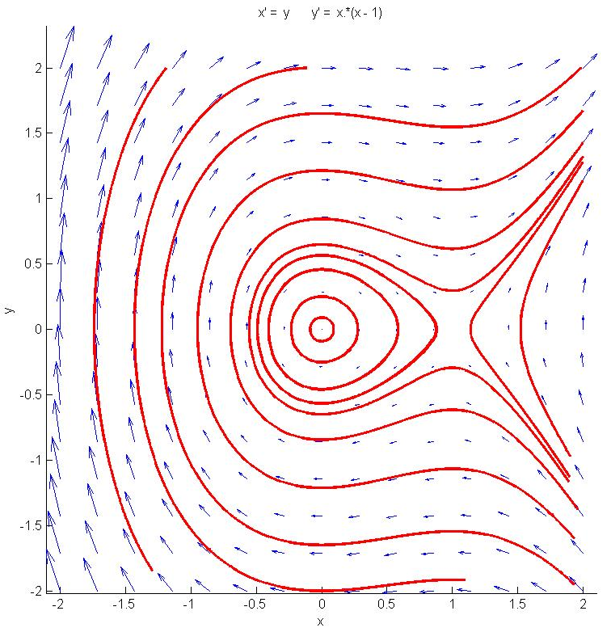
Example 1

F(x,y) = y
G(x,y) = x (x − 1)

the saddle is generic but the center is not.
Nevertheless, the non-linear system has the same type of equilibrium at both points.

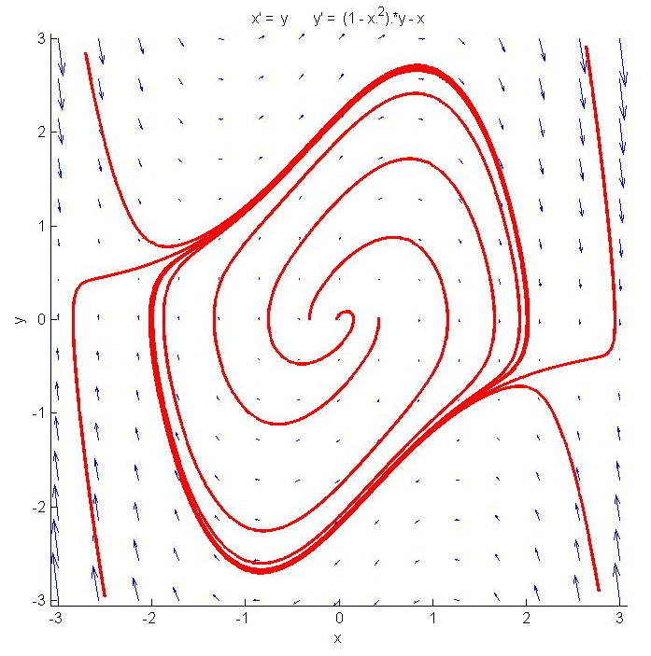
Example 2 (van der Pol oscillator)

F(x,y) = y
G(x,y) = μ(1 − x²) y − x

the equilibrium is a source spiral and generic for μ < 2,
and it is a source node and generic for μ > 2.

