Linear Systems of Autonomous First-Order DE's

Part A: Examples

The system of DEs

$\left\{\begin{matrix}\frac{\text{dx}}{\text{dt}}=F(x,y) \\ \frac{\text{dy}}{\text{dt}}=G(x,y)\end{matrix}\right.$

where F and G are two given functions of x and y is called a system of first-order autonomous DEs.

t is the independent variable.
There are two dependent variables, x and y.
The system of DEs describes the simultaneous evolution of x and y in time.
The plane (x,y) is called the phase plane.

We represent the behavior of the system in the phase plane by plotting a few trajectories (x(t), y(t)), each starting at a different point (x(0), y(0)), with t running over a suitable interval. The independent variable t does not appear explicitly in the phase plane.

We draw the velocity field (dx/dt, dy/dt) = (F, G) = (F(x, y), G(x, y)) at regularly spaced points (x, y) in the phase plane.

This velocity field is sometimes called a vector field or direction field. The slope dy/dx of the trajectory through point (x,y) is y'/x' = G(x,y)/F(x,y). As usual, x' is short for dx/dt. Alternatively, we will sometimes use the notation $\overset{˙}{x}$ for dx/dt.

The loci (generally curves, or lines) of constant slope in the phase plane are called isoclines. Of particular interest are the loci where one of the two derivatives is 0. These loci are called nullclines.

The locus of the points (x, y) such that dx/dt = 0, i.e., F(x,y) = 0, is called the vertical nullcline, or V-nullcline, because the trajectories there all have vertical slope.

Similarly, the locus of the points (x, y) such that dy/dt = 0, i.e., G(x,y) = 0, is called the horizontal nullcline, or H-nullcline, because the trajectories there all have horizontal slope.

The trajectories, velocity field and nullclines make up a phase portrait of the system.

If both F and G are linear functions of x and y, the system is called a linear system of first-order autonomous DEs. The following are examples of such systems. The phase portraits were created by Linear_System.m.

Example 1:

F(x,y) = x and G(x,y) = y. Thus:

(1) $\left\{\begin{matrix}\frac{\text{dx}}{\text{dt}}=x \\ \frac{\text{dy}}{\text{dt}}=y\end{matrix}\right.$

The solution to this system of simultaneous DEs is:

$$\left\{\begin{matrix}x=C\text{exp}(t) \\ y=D\text{exp}(t)\end{matrix}\right.$$

where C and D are two arbitrary constants. In case the initial values are specified—we then have an "Initial Value Problem"—we get: C = x(0) and D = y(0).

Phase portrait of System (1)
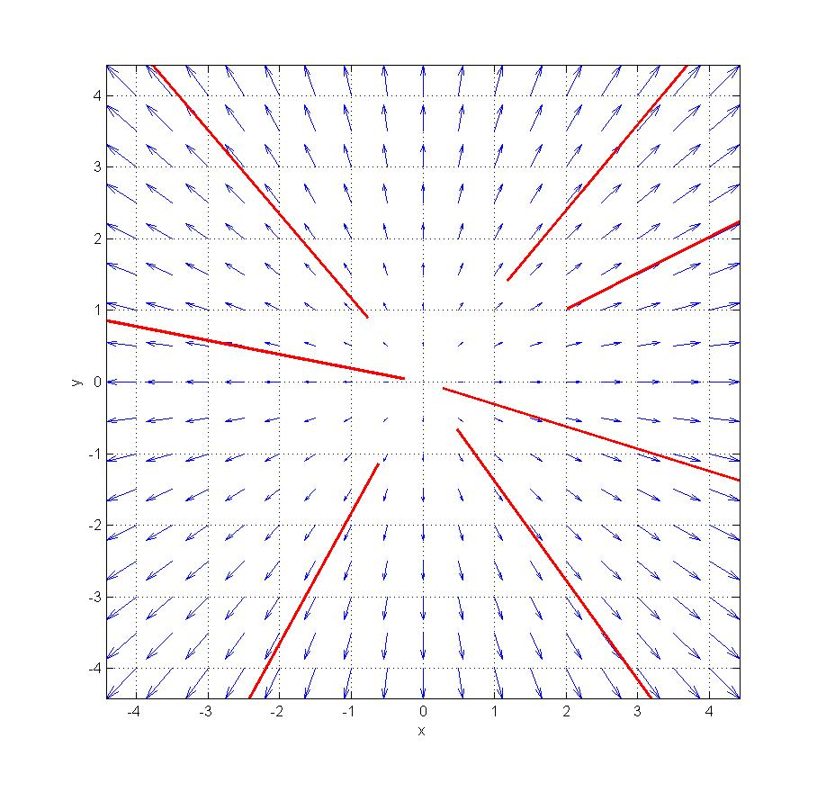

The V-nullcline is the y-axis, and the H-nullcline is the x-axis. The origin, which is the intersection of the two nullclines, is an equilibrium point. That is, (x(t), y(t)) ≡ (0, 0) is a solution of this system of DEs.

From the analytical form of the solutions, and from the phase portrait, we see that any given solution satisfies y(t)/x(t) = D/C = constant. Thus, all trajectories are segments of lines through the origin. This type of equilibrium point is therefore called a star node.

The phase portrait does not illustrate the behavior of the point (x(t), y(t)) as a function of time. To visualize this time behavior, we plot x(t) and y(t)) as a function of t.

We can do this for any trajectory of interest. For instance, one of the trajectories in the above phase portrait starts at point (C, D) = (x(0), y(0)) = (2, 1). This trajectory is a segment of line of slope .5. The time behavior on this trajectory is as follows:
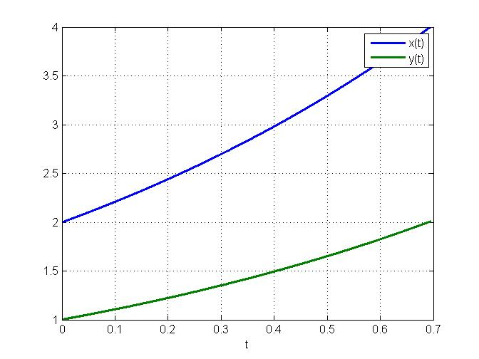
Note that y remains exactly equal to x/2 at all times.

The time behavior on the trajectory that starts at (.2, −.1) is:
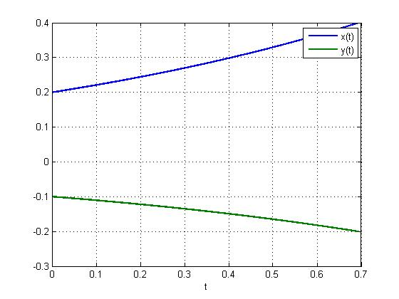
In this case, y remains exactly equal to – x/2 at all times.
Example 2:

F(x,y) = 2x and G(x,y) = y. Thus:

(2) $\left\{\begin{matrix}\frac{\text{dx}}{\text{dt}}=x \\ \frac{\text{dy}}{\text{dt}}=2y\end{matrix}\right.$

The solution to this system of simultaneous DEs is:

$$\left\{\begin{matrix}x=C\text{exp}(t) \\ y=D\text{exp}(2t)\end{matrix}\right.$$

where C and D are two arbitrary constants. The constants C and D are:
C = x(0); D = y(0).

Phase portrait of System (2)
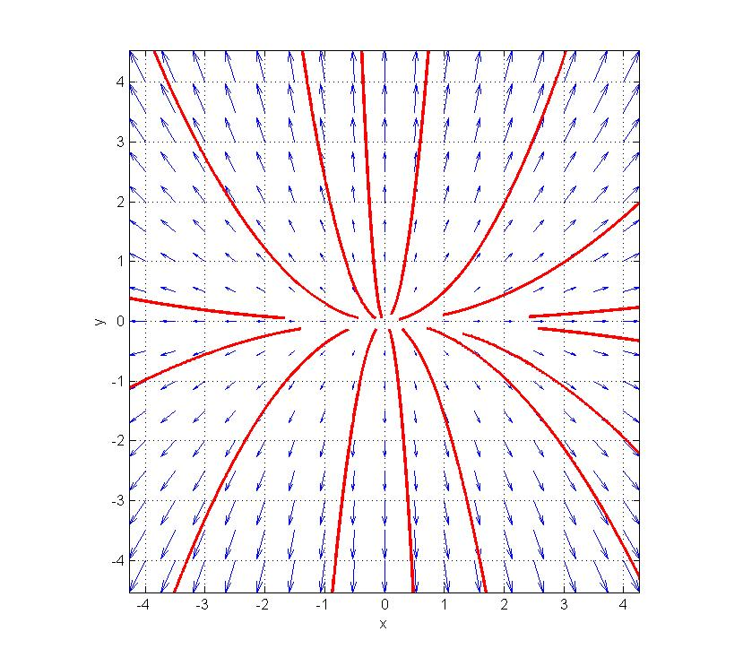
The H- and V-nullclines are as in System (1), but the trajectories are now parabolas instead of lines. Indeed, from the form of y(t) and x(t) given above, we see that the equation of the trajectory starting at (x₀, y₀) is y = k x², where k = D/C² = y₀/x₀².

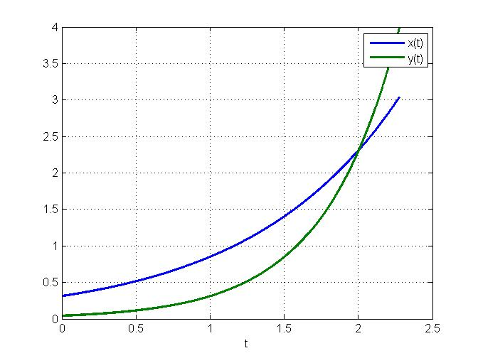
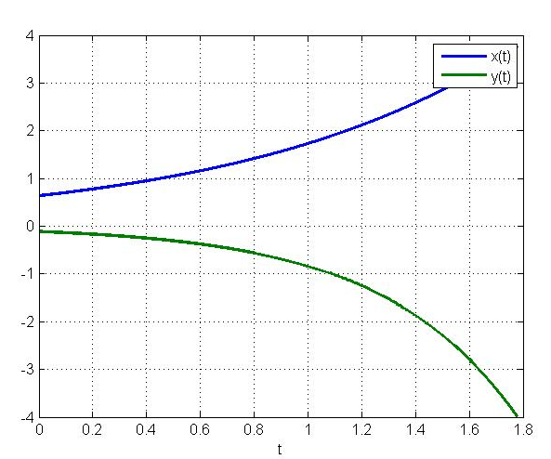
Time behavior of System (2) along two trajectories

Note that (0,0) is again an equilibrium point of the system. Indeed, it is the solution that we get if we are given the initial state (x₀, y₀) = (0, 0).

The equilibrium solution, both in System (1) and in System (2), is unstable: any perturbation away from equilibrium, however small, causes the state to fly off to infinity.

The type of equilibrium exhibited by System (2) is called a node. As mentioned, the equilibrium in System (1) is a star node.

Systems (1) and (2) are examples of linear systems, where both F and G are linear functions of x and y. The general form of a linear system of first-order autnonomous DEs is:

$$\left\{\begin{matrix}\frac{\text{dx}}{\text{dt}}=\text{ax}+\text{by}+e \\ \frac{\text{dy}}{\text{dt}}=\text{cx}+\text{dy}+f\end{matrix}\right.$$

where a, b, c, d, e, f are constants. These six constants are called the parameters of the system.

If both e and f are 0, as in Systems (1) and (2), the system is called homogeneous. Otherwise, it is called non-homogeneous.

In Systems (1) and (2), F(x, y) is a function of x only, and G(x, y) is a function of y only. As a result, the two equations that make up the system are decoupled: the behavior of x is independent of y, and vice-versa. This makes up for particularly simple behavior, as each equation can be analyzed separately from the other.

More interesting cases arise when the equations are coupled, i.e., at least one of the two function F and G is a function of both variables x and y. In terms of the parameters a, b, c, d, this means that at least one of b and c are non-zero.

Using matrix notation:

x = $\left(\begin{matrix}x \\ y\end{matrix}\right)$, A = $\left(\begin{matrix}a & b \\ c & d\end{matrix}\right)$, e = $\left(\begin{matrix}e \\ f\end{matrix}\right)$,

our system reads

dx/dt = Ax + e,

where Ax is the product of matrix A by vector x.

The following are examples of phase portraits (and time behavior) for various values of the four parameters making up matrix A. In all cases, both e and f are 0, i.e., the system is homogeneous linear in addition to being autonomous.

Note that the decoupled Systems (1) and (2) are given by A = $\left(\begin{matrix}1 & 0 \\ 0 & 1\end{matrix}\right)$ and A = $\left(\begin{matrix}1 & 0 \\ 0 & 2\end{matrix}\right)$ respectively: all non-diagonal elements of A are 0. This exactly characterizes decoupled systems in matrix notation.

Example (3): dx/dt = Ax with A = $\left(\begin{matrix}0 & 0 \\ 0 & 1\end{matrix}\right)$

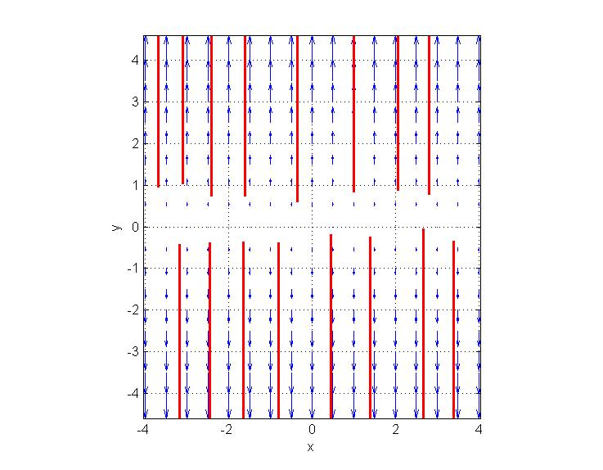

System (3) is also decoupled, and it is even simpler than Systems (1) and (2). The first equation says that dx/dt = 0, hence x is constant.

Each point on the x-axis is an equilibrium, and we see that these are unstable equilibria. Indeed, y(t) is given by y(t) = y₀ exp(t), so when t goes to + ∝ y goes to + ∝ or to − ∝, depending on the sign of y₀.

Example (4):

dx/dt = Ax with A = $\left(\begin{matrix}1 & 1 \\ 1 & 1\end{matrix}\right)$

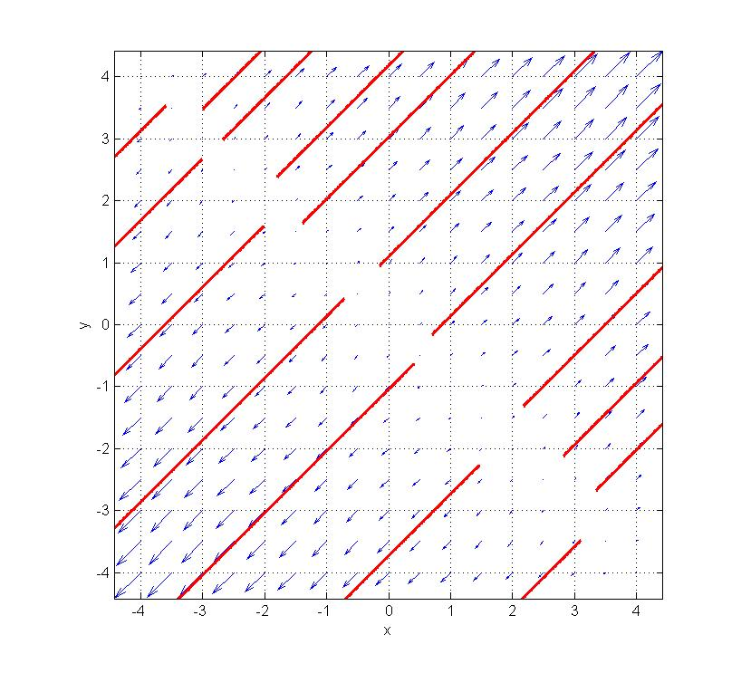

In this system x and y are coupled, since matrix A has non-zero off-diagonal terms.

The H-nullcline and the V-nullcline are both equal to the line y = −x.

Thus, each point on the line y = −x is an equilibrium point, and we see that these equilibria are unstable.

Note that the phase portrait of System (4) is a mere rotation by 45 degrees of the phase portrait of System (3).
Example (5): dx/dt = Ax with A = $\left(\begin{matrix}1 & 0 \\ 0 & −1\end{matrix}\right)$
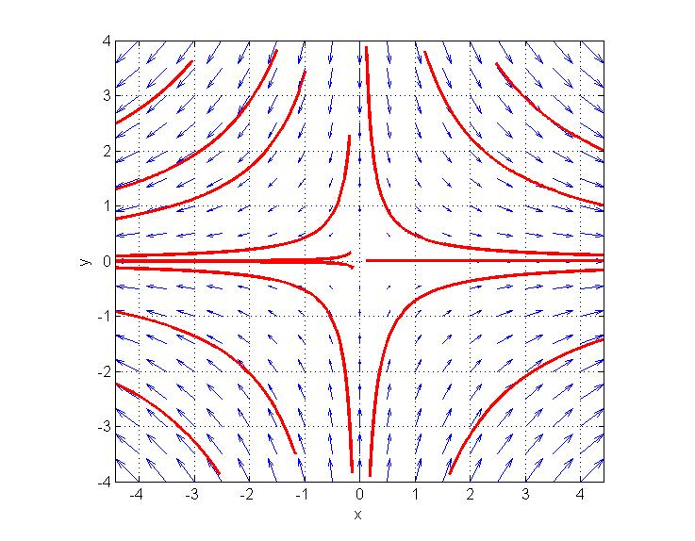
Here x and y are decoupled again, and the solution is simply:

$$\left\{\begin{matrix}x(t)=C\text{exp}(t) \\ y(t)=D\text{exp}(−t)\end{matrix}\right.$$

The H-nullcline is the x-axis, and the V-nullcline is the y-axis. The only equilibrium point is the origin, and it is unstable. This type of equilibrium is called a saddle point, because the trajectories near it resemble the trajectories of beads rolling down a saddle, viewed from above.
Time behavior of System (5) on two trajectories
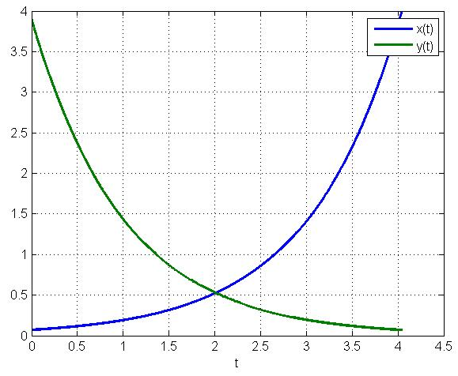
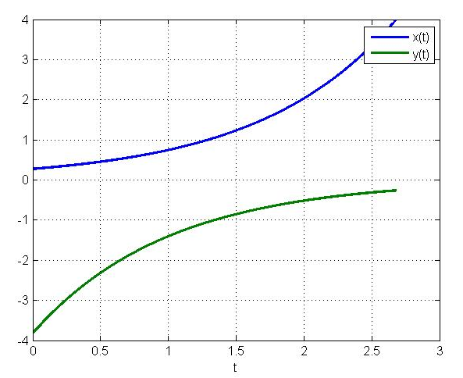
Example (6):

dx/dt = Ax with A = $\left(\begin{matrix}1 & −2 \\ 1 & 1\end{matrix}\right)$

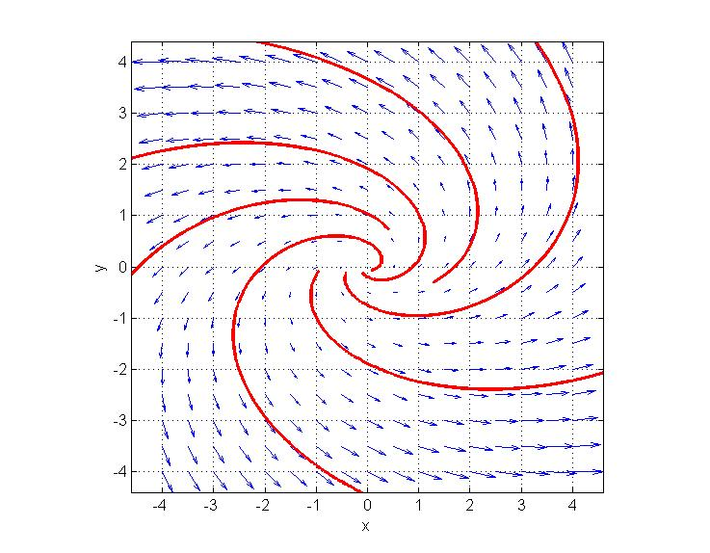

The H-nullcline is the line y = −x, and the V-nullcline is the line y = x/2. The only equilibrium point, again, is the origin, and, again, it is unstable. This type of equilibrium is called a spiral point.

Time behavior of System (6) on two trajectories
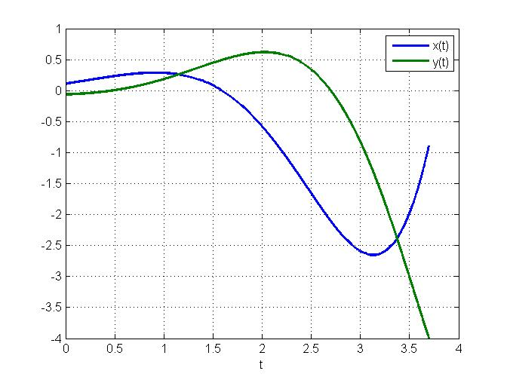
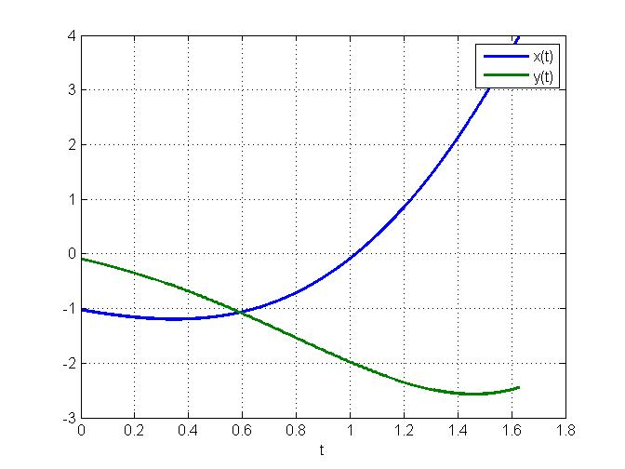
Example (7): dx/dt = Ax with A = $\left(\begin{matrix}−1 & 2 \\ −1 & −1\end{matrix}\right)$
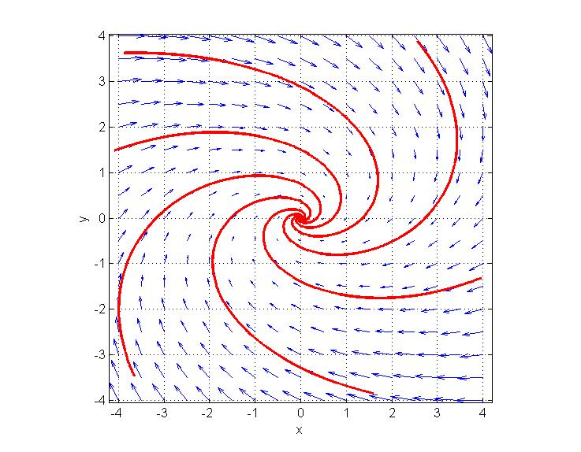
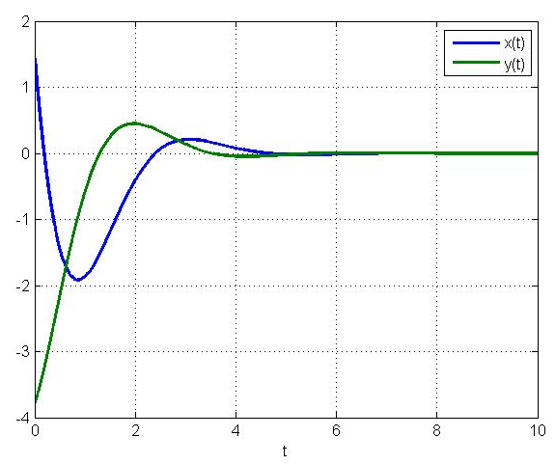
Time behavior of System (7) on two trajectories
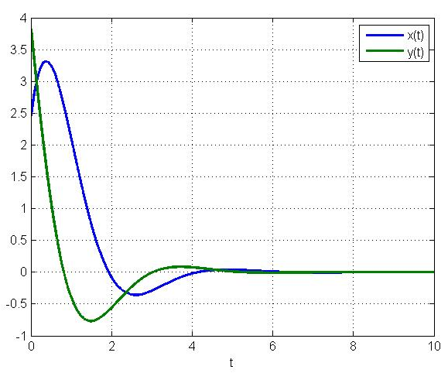

Note that the matrix of parameters for System (7) is the same as the matrix of System (6), except that the signs of all four parameters have been reversed. As a result, the phase portraits are the same except that the trajectories go in reverse directions. The origin is now a stable spiral point. (Technically, the trajectories approach this attractor by spiraling around it infinitely many times.)

Similarly, for each type of unstable equilibrium other than a saddle illustrated above, reversing the signs of the parameters will create a stable equilibrium of same type. Saddles are always unstable.
Example (8): dx/dt = Ax with A = $\left(\begin{matrix}1 & 3 \\ −2 & −1\end{matrix}\right)$
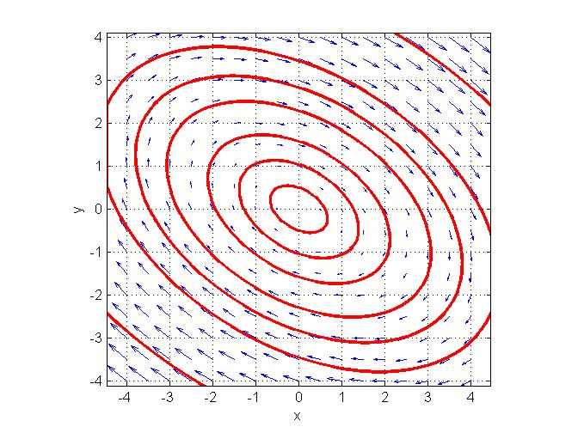

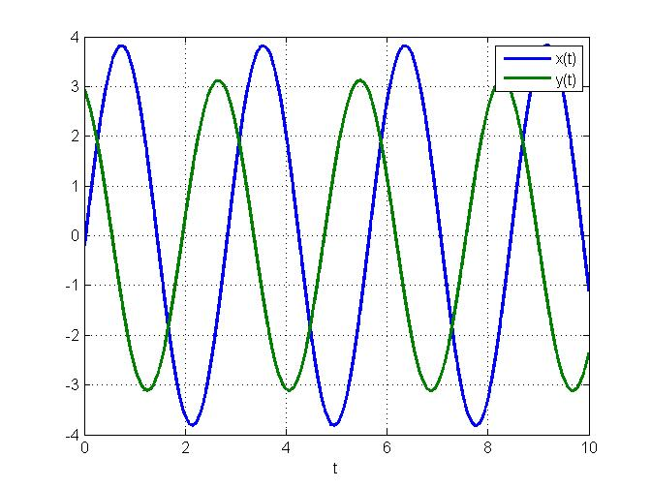
Time behavior of System (8) on two trajectories
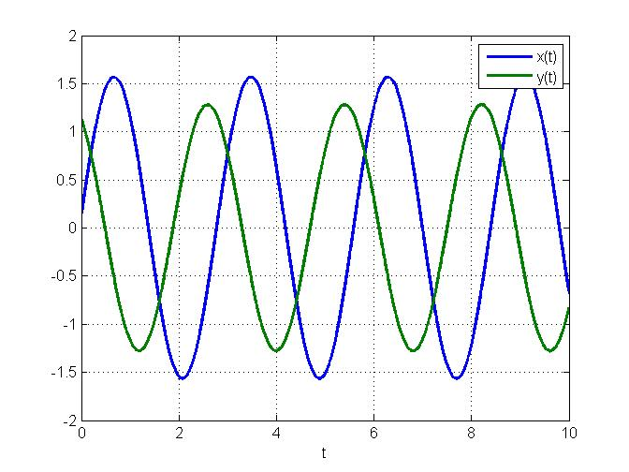

Again, the origin is the only equilibrium point, and it is called a center. Trajectories are neither "repelled" by the equilibrium as in unstable systems, nor are they attracted by it as in a stable system. Rather, they remain at finite distance from the origin. This type of equilibrium is therefore called neutrally stable.

Part B: Eigenvector Analysis

Consider the homogeneous linear system

(1) $\left\{\begin{matrix}\frac{\text{dx}}{\text{dt}}=2x+2y \\ \frac{\text{dy}}{\text{dt}}=x+3y\end{matrix}\right.$

The following is a phase portrait, with nullclines and separatrices, created by Linear_System.m.
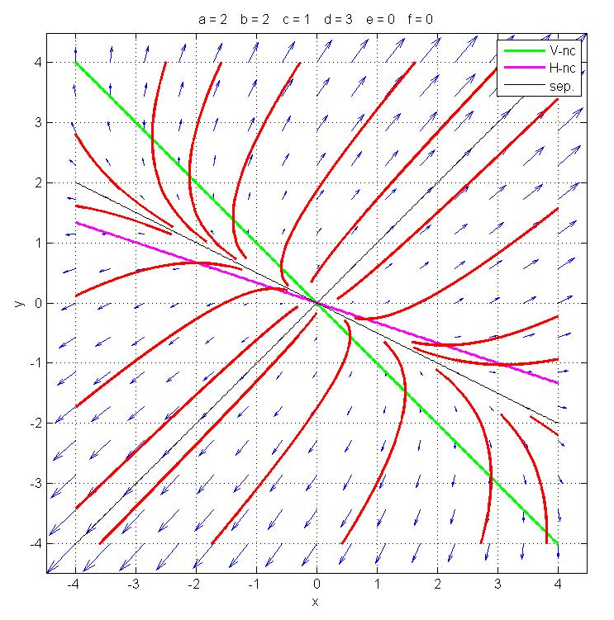
From the phase portrait we see that there is an equilibrium point which is of the unstable-node type.

How do we solve this system analytically?

We might get lucky with a little guessing… Let's try a solution of the form:

$$\left\{\begin{matrix}x(t)=x_{1}\text{exp}(t) \\ y(t)=y_{1}\text{exp}(t)\end{matrix}\right.$$

Substituting into (1), and dividing all members by exp(t), we get

$$\left\{\begin{matrix}x_{1}=2x_{1}+2y_{1} \\ y_{1}=x_{1}+3y_{1}\end{matrix}\right.$$

So our guess leads us to an algebraic linear system of two equations with two unknowns. This system is equivalent to the single equation:

x₁ = − 2y₁

with the general solution (x₁, y₁) = (k₁, −.5k₁), where k₁ is any real number.

We can easily check that (k₁e^{t} , −.5k₁e^{t}) is indeed a solution, by substituting it into (1). It is the solution with initial state (k₁, −.5k₁). Looking at the phase portrait, we see that this solution lies on one of the two separatrices (drawn in black). It goes to (+∝, −∝) if k₁ > 0, and to (−∝, +∝) if k₁ < 0.

Can we find another solution with another guess of the same form?
Let's try:

$$\left\{\begin{matrix}x(t)=x_{2}\text{exp}(2t) \\ y(t)=y_{2}\text{exp}(2t)\end{matrix}\right.$$

We get the algebraic system

$$\left\{\begin{matrix}2x_{2}=2x_{2}+2y_{2} \\ 2y_{2}=x_{2}+3y_{2}\end{matrix}\right.$$

whose only solution is (x₂, y₂) = (0, 0). So this guess didn’t work, since it gives us only the trivial solution, i.e., the equilibrium point.

We might do more guesses, and sooner or later, by trial and error, we would actually find that the exponential function exp(4t) happens to work. Indeed,

$$\left\{\begin{matrix}x(t)=x_{2}\text{exp}(4t) \\ y(t)=y_{2}\text{exp}(4t)\end{matrix}\right.$$

leads us to the single algebraic equation

x₂ = y₂

which has the general solution (x₂, y₂) = (k₂, k₂).

Substituting into (1), we can check that (k₂e^{4t}, k₂e^{4t}) is indeed a solution. It is the solution with initial state (k₂, k₂). Looking at the phase portrait, we see that this solution lies on the other separatrix. It goes to (+∝, +∝) if k₂ > 0, and to (−∝, −∝) if k₂ < 0.

Question 1: Why did the functions exp(t) and exp(4t) work, whereas exp(2t) didn't?

Question 2: How do we find the solutions without guessing?

Question 3: Is there a way to find the general solution from the two particular solutions that we found?

The last question is easy to answer, using linearity of the system of DE's. We can easily check that the following is true:

Theorem: If the functions x₁(t), y₁(t), x₂(t), and y₂(t) are such that the pair (x₁(t), y₁(t)) and the pair (x₂(t), y₂(t)) are both solutions of a given homogeneous linear system of DE's, than so is their sum, the pair (x₁(t) + x₂(t) , y₁(t) + y₂(t)).

As a result of this theorem, we see that, for any two real numbers k₁ and k₂, the pair of functions
(*) $\left\{\begin{matrix}x(t)=k_{1}\text{exp}(t)+k_{2}\text{exp}(4t) \\ y(t)=−\text{.}5k_{1}\text{exp}(t)+k_{2}\text{exp}(4t)\end{matrix}\right.$

is a solution of (1). It is the solution with initial state x₀ = k₁ + k₂ and y₀ = −.5k₁ + k₂. This can be checked by substitution.

Going back to the phase portrait, we see that this solution is the geometric sum of one solution that runs along one of the separatrices, and another solution that runs along the other separatrix. The geometric sum is obtained by drawing a parallelogram with two of its four edges on the separatrices.

When given any initial condition (x₀, y₀) in the phase plane, we can always find a pair of real numbers k₁ and k₂ such that k₁ + k₂ = x₀ and −.5k₁ + k₂ = y₀. Thus, solutions of the form (*) solve all IVP's for System (1).

We now turn to Questions 1 and 2 above.

Consider the general homogeneous linear system of first-order autonomous DE's:

(2) $\left\{\begin{matrix}\frac{\text{dx}}{\text{dt}}=\text{ax}+\text{by} \\ \frac{\text{dy}}{\text{dt}}=\text{cx}+\text{dy}\end{matrix}\right.$

i.e., in matrix form:

dx/dt = Ax,

with x = $\left(\begin{matrix}x \\ y\end{matrix}\right)$ and A = $\left(\begin{matrix}a & b \\ c & d\end{matrix}\right)$.

We will look for solutions of the form:

$$\left\{\begin{matrix}x(t)=x_{0}\text{exp}(λt) \\ y(t)=y_{0}\text{exp}(λt)\end{matrix}\right.$$

where x₀, y₀ and λ are real (or complex) numbers. Substituting this solution into (2), we get (after dividing all members by exp(λt) ):

$\left\{\begin{matrix}{λx}_{0}={\text{ax}}_{0}+{\text{by}}_{0} \\ {λy}_{0}={\text{cx}}_{0}+{\text{dy}}_{0}\end{matrix}\right.$ in matrix notation: $A\left(\begin{matrix}x_{0} \\ y_{0}\end{matrix}\right)=λ\left(\begin{matrix}x_{0} \\ y_{0}\end{matrix}\right)$,

or:

(3) $\left\{\begin{matrix}(a−λ)x_{0}+{\text{by}}_{0}=0 \\ {\text{cx}}_{0}+(d−λ)y_{0}=0\end{matrix}\right.$

Again, we get an algebraic system of two equations, only this time it has three unknowns: x₀, y₀ and λ.

Now, given λ, we know from linear algebra that in order for this system to have a non-trivial solution (x₀, y₀), the determinant of (3) has to be 0. That is:

(a −λ )(d −λ ) − bc = 0,

or:

(4) λ² − Tλ + D = 0,

where T = a + d and D = ad − bc.

For any 2-by-2 matrix A = $\left(\begin{matrix}a & b \\ c & d\end{matrix}\right)$, T = a + d is called the trace of A, and D = ad − bc is its determinant. The quadratic polynomial in p(λ) = λ² − Tλ + D, is called the characteristic polynomial of A.

We first solve Equation (4). Its roots, λ₁ and λ₂, are called the eigenvalues of matrix A. We will assume that p(λ) indeed has two distinct roots.

For each of these two eigenvalues, we then solve System (3). A non-zero solution (x₀, y₀) of System (3) for eigenvalue λ_{i} is called an eigenvector associated with eigenvalue λ_{i}. Note that if we multiply an eigenvector by a constant we still get an eigenvector associated with the same eigenvalue. (This is best seen from the matrix form of (3).)

We now put it all together. Let (x₁, y₁) be an eigenvector associated with eigenvalue λ₁, and let (x₂, y₂) be an eigenvector associated with eigenvalue λ₂. We know that such eigenvectors exist, precisely because λ₁ and λ₂ are the eigenvalues of matrix A, i.e., each one of them makes the determinant of algebraic System (3) equal to 0. By construction, if the three numbers x₀, y₀ and λ solve algebraic System (3), then

$$\left\{\begin{matrix}x(t)=x_{0}\text{exp}(λt) \\ y(t)=y_{0}\text{exp}(λt)\end{matrix}\right.$$

is a solution of DE System (2).

Since we can multiply any eigenvector by a constant, we get that, for any two real numbers k₁ and k₂, the pair of functions $\left(\begin{matrix}k_{1}x_{1}\text{exp}(λ_{1}t) \\ k_{1}y_{1}\text{exp}(λ_{1}t)\end{matrix}\right)$ and the pair of functions $\left(\begin{matrix}k_{2}x_{2}\text{exp}(λ_{2}t) \\ k_{2}y_{2}\text{exp}(λ_{2}t)\end{matrix}\right)$ are both solutions of System (2).

By the above theorem, so is their sum, the pair of functions:

$\left(\begin{matrix}k_{1}x_{1}\text{exp}(λ_{1}t)+k_{2}x_{2}\text{exp}(λ_{2}t) \\ k_{1}y_{1}\text{exp}(λ_{1}t)+k_{2}y_{2}\text{exp}(λ_{2}t)\end{matrix}\right)$.

This sum is the general solution to System (2), the general homogeneous linear system of first-order autonomous DE's. Given any initial value (x₀, y₀) in the phase plane, we can always find two real numbers k₁ and k₂ such that k₁x₁ + k₂x₂ = x₀ and k₁ y₁ + k₂y₂ = y₀, and solve the IVP in this way.

Remember that we had to assume that p(λ) = λ² − Tλ + D, the characteristic polynomial of A, had two distinct roots, i.e., that matrix A had two distinct eigenvalues λ₁ and λ₂. If, on the other hand, p(λ) has a double root—we then say that A has a repeated eigenvalue—the picture might be a bit more complicated. However, this is a special case that doesn't present itself all too often, and we shall not discuss it in detail.

When p(λ) has two distinct roots, forming the two eigenvalues λ₁ and λ₂ of matrix A, we can write:

p(λ) = λ² − Tλ + D = (λ − λ₁) (λ − λ₂).

We therefore see that T = a + d, the trace of A, is equal to the sum of the eigenvalues, while D = ad − bc, the determinant of A, is equal to the product of the eigenvalues.

Since the solutions are sums of terms of the form exp(λt) where λ is an eigenvalue, the stability of the equilibrium is determined by the signs of the eigenvalues, or of their real part if they are complex.

Indeed, we need to distinguish the case where the discriminant of p, Δ = T² − 4D, is positive, implying that the eigenvalues λ₁ and λ₂ are real-valued, from the case where Δ is negative, implying that the eigenvalues λ₁ and λ₂ are a pair of complex-conjugate numbers.

System (1) above illustrates the case where λ₁ and λ₂ are distinct and real-valued. Since both are positive, in this case +1 and +4, the equilibrium is an unstable node. The eigenvector (1, 1) which has the largest eigenvalue +4, determines the fast eigendirection. All trajectories leave the equilibrium tangent to the slow eigenvector, in this case (1, −.5).

Note that the sign of the determinant D = ad − bc tells us whether λ₁ and λ₂ have the same sign, since D = λ₁λ₂. In System (1), D = 4, hence λ₁ and λ₂ are of same sign.

If D = λ₁λ₂> 0 and the eigenvalues are of same sign, the sign of the trace T = a + d tells us whether they are positive or negative, since T = λ₁ + λ₂. In System (1), T = 5, hence λ₁ and λ₂ are of positive sign.

The following diagram shows the location of System (1) in the (T, D) plane (red star):
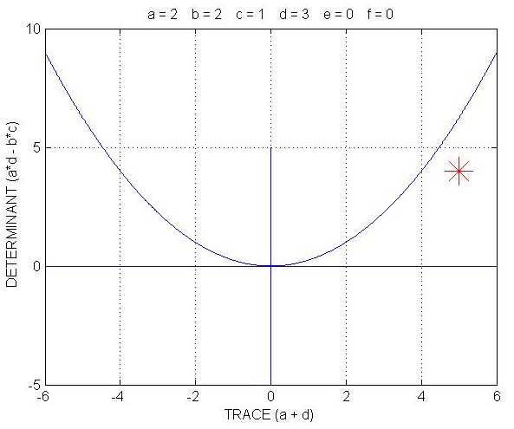
The equation of the parabola is:

D = T²/4
so the (T, D) points under the parabola correspond to systems with two distinct real eigenvalues.

The diagram immediately shows this, as well as the fact that both T and D are positive, hence the equilibrium is an unstable node.

In contrast, consider:

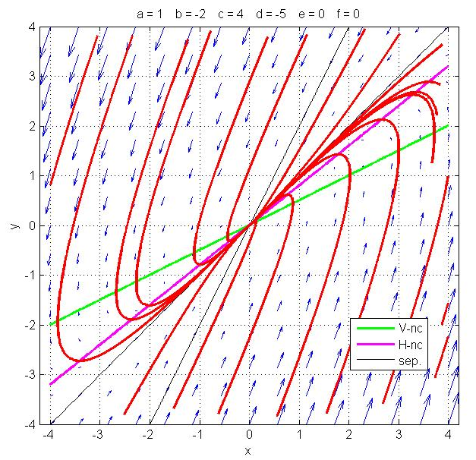
(5) $\left\{\begin{matrix}\frac{\text{dx}}{\text{dt}}=x−2y \\ \frac{\text{dy}}{\text{dt}}=4x−5y\end{matrix}\right.$

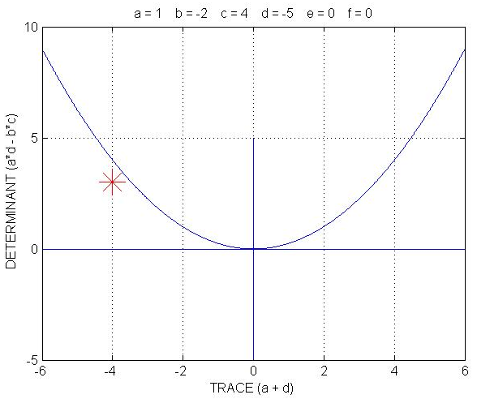
In this case D = 3 and T = − 4. Hence the two distinct real-valued roots are of same sign and negative. Hence the equilibrium is a stable node.

As another example, consider:

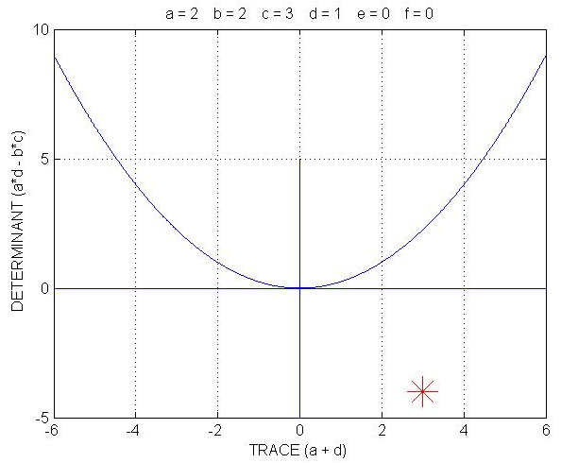
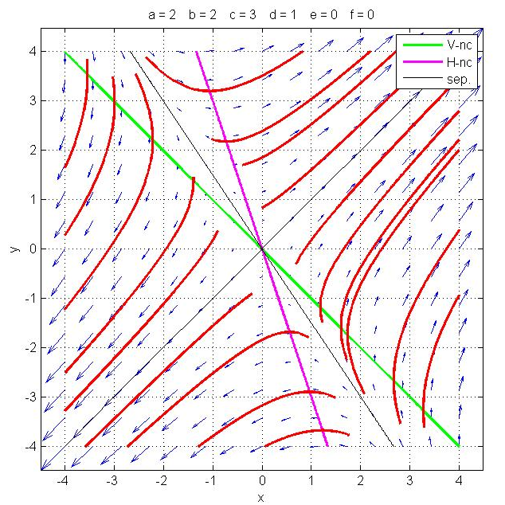
(6) $\left\{\begin{matrix}\frac{\text{dx}}{\text{dt}}=2x+2y \\ \frac{\text{dy}}{\text{dt}}=3x+y\end{matrix}\right.$

D is negative, and the two distinct real eigenvalues (system is under the parabola) are of opposite signs, hence we have a saddle point.

As a final example, consider:
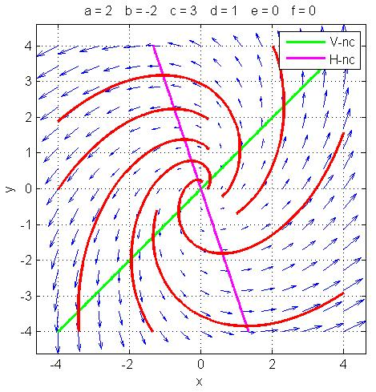
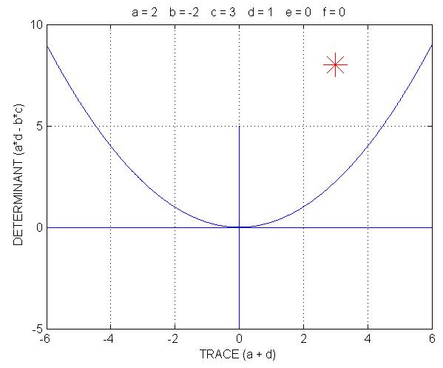
(7) $\left\{\begin{matrix}\frac{\text{dx}}{\text{dt}}=2x−2y \\ \frac{\text{dy}}{\text{dt}}=3x+y\end{matrix}\right.$
Here we have T = 3, D = 8. The system is above the parabola, hence the eigenvalues are a complex-conjugate pair and the trajectories are spirals. They are unstable, because the real part of the eigenvalues is positive.
Similarly, a system above the parabola in the (T, D) plane but with negative T has a stable spiral equilibrium, since its eigenvalues have negative real part.

Finally, a system on the positive D axis has purely imaginary eigenvalues, hence its equilibrium is a center, which is neutrally stable.

The following diagram summarizes all the cases of interest:

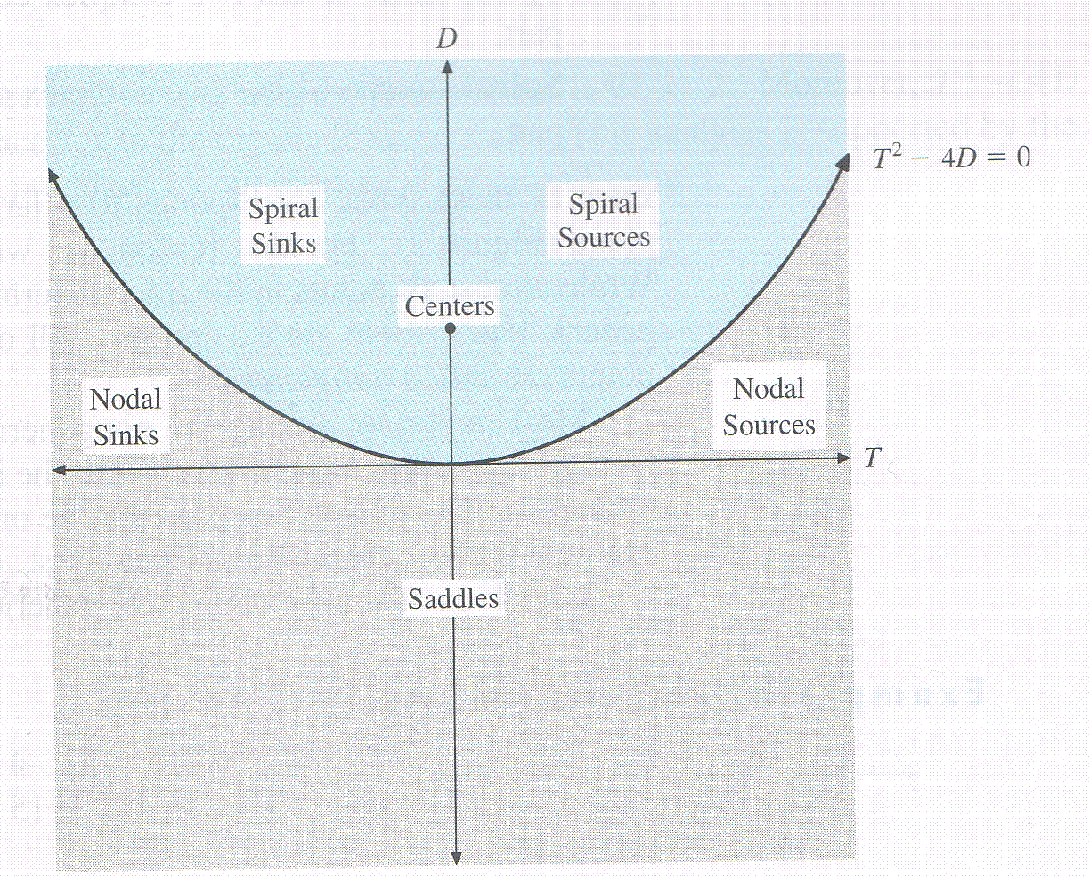

Note that source is another term for unstable point attractor, and sink for stable point attractor.

Remark on non-homogeneous systems:

The nonhomogeneous system

$\left\{\begin{matrix}\frac{\text{dx}}{\text{dt}}=\text{ax}+\text{by}+e \\ \frac{\text{dy}}{\text{dt}}=\text{cx}+\text{dy}+f\end{matrix}\right.$

has the same phase portrait as that of its homogeneous counterpart, System (2), only shifted so as to get the correct equilibrium point. The equilibrium point can be determined, as usual, as the intersection of the nullclines.

For instance:

(8) $\left\{\begin{matrix}\frac{\text{dx}}{\text{dt}}=2x−2y+2 \\ \frac{\text{dy}}{\text{dt}}=3x+y−1\end{matrix}\right.$

has the same phase portrait as System (7), only shifted upward, since the equilibrium point is now (0, 1) instead of (0, 0).

