The FitzHugh-Nagumo Model

This model captures much of the non-linear behavior of spike generation. It does this in a simplified, "ad-hoc," 2-dimensional setting, allowing phase-plane analysis. (In contrast, the Hodgkin-Huxley model, being much closer to the biological mechanism, operates in 4 dimensions.)

x' = F(x,y) = x − x³/3 – y + Input
y' = G(x,y) = 0.08(x + 0.7 – 0.8y)

x(t): membrane potential, or voltage (denoted V in the code, fitzhugh_nagumo.m)
y(t): ad hoc "recovery" variable (denoted W in the code)

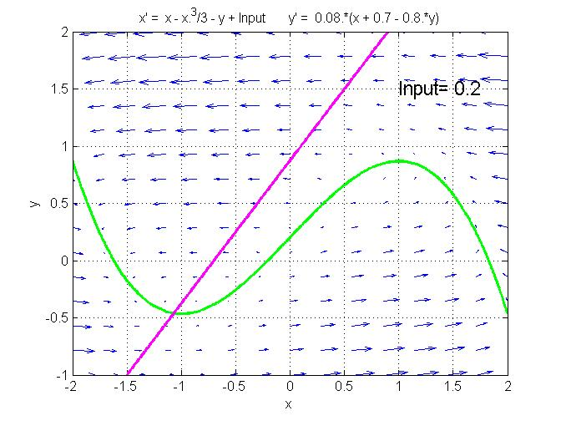

The hump in the cubic vertical nullcline creates a limited region in the phase space where x "regenerates." This may be seen as positive feed-back: if x starts large enough, it increases rapidly, until it reaches the right branch of the cubic. It crosses the branch, and stays closes to it. The recovery variable then starts to increase, and this pushes x down, until it has to leave the right branch of the nullcline and is forced to jump to the left branch. Note the small coefficient, 0.08, in y'. This small coefficient, essentially the ratio between the time scales for x motion and for y motion, causes trajectories to be nearly horizontal except when they get close to the vertical nullcline. Also, motion will be faster along these near-horizontal segments than on segments that hug the vertical nullcline.

In its details, the behavior depends on where exactly the two nullclines cross each other, w.r.t. the minimum of the cubic vertical nullcline. This in turn depends on the parameter Input, interpreted as the amount of current injected into the neuron.

Thus:

Phase portrait with: Input = -1
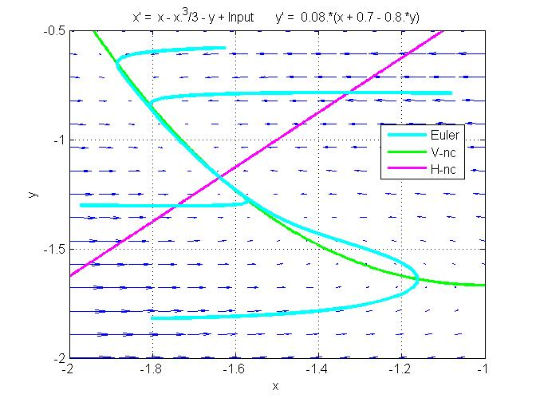

If Input is low, the intersection of the nullclines takes place on the left branch of the cubic NC, and the equilibrium is a stable node.

Phase portrait with: Input = .2
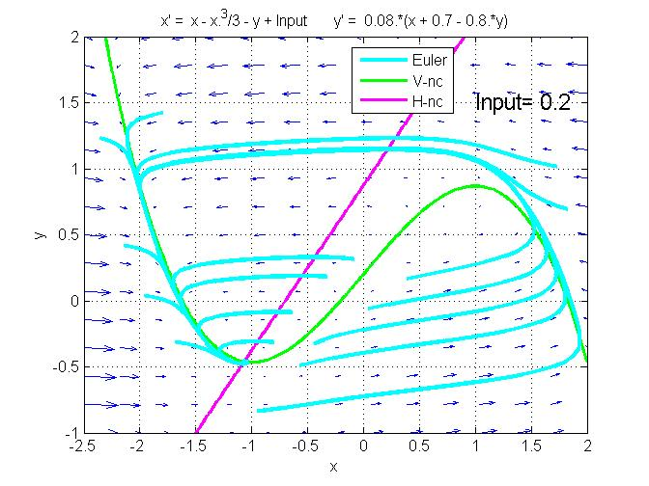

With Input = .2, the equilibrium is still stable, but it is now a spiral.

If the membrane potential is started at a high enough value, the neuron fires a single "spike," and then x goes back to its resting level.
Phase portrait with: Input = .4

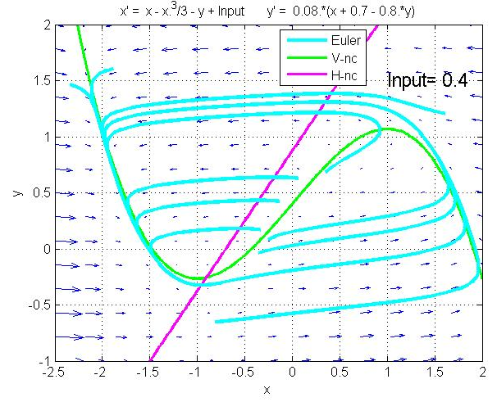

With Input = .4, the cubic has moved up a bit, and as a result the intersection point is now slightly to the right of the minimum. It has become an unstable equililibrium, a repelling spiral.

Between these two values of Input, namely .3 and .4, a qualitative change of behavior takes place. In the theory of dynamical systems, this is called a bifurcation. Careful analysis shows that the bifurcation takes place around Input = 0.34. Bifuractions are classified in different types. The bifurcation observed here is called a Hopf (or Andronov-Hopf) bifucation. (It is a so-called subcritical Hopf bifurcation—see below).

More detailed analysis of these various cases follows…

Observations for Input = 0:

The phase portrait shows that the equilibrium point is stable. This is confirmed by the T-D analysis, which further shows that it is a spiral sink. The spiraling nature of the equilibrium cannot be seen in the phase portrait unless it is enlarged around the equilibrium. The reason is that the system is very close to the node-spiral boundary curve (parabola) in the T-D plane.

We see from the time plots and from the phase portrait that trajectories starting at a small negative value V₀ decay to a large negative value (interpreted as the resting potential) directly, whereas trajectories starting at a positive value, however small, first undergo a sharp increase of V before decaying and converging to the resting value (about – 1.2). This behavior is characteristic of a neuron’s excitable membrane: when V is pushed above a given threshold, an action potential is generated, and then V goes back to its resting value. Here the threshold is 0. All the trajectories here used W₀ = 0. For a different W₀ we would get a different threshold for V.

Observations for Input = .3:

There is no major difference between this case and the case Input = 0. The equilibrium is still stable, and there is a theshold value, which is about – .31 for W₀ = 0.

There is however a minor difference. The T-D diagram shows that the system has moved away from the spiral-node boundary (parabola) and has come closer to the sink-source boundary (D axis). As a consequence, the spiraling behavior is more pronounced. This is seen on the phase portrait and on the time plots.

Physically, this behavior is characteristic of an underdamped system. It is not a realistic feature of the membrane potential of a neuron. In real neurons, the membrane potential, after a spike, returns to equilibrium without oscillation.

Observations for Input = .4:

There is a major difference between this case and the cases Input = 0 and Input = .3. As is clear from the phase portrait, from the T-D diagram and from the time plots, the equilibrium is now a spiral source, and the asymptotic behavior is characterized by a large limit cycle. Thus, whatever the initial condition, the system will eventually oscillate periodically.

This behavior is characteristic of a neuron in which a large enough depolarizing, i.e., positive, current is injected. The neuron fires action potentials at a fixed frequency, which means that its membrane potential undergoes large periodic oscillations.

Note however that the shape of the oscillations of the FitzHugh-Nagumo model are not exactly like a sequence of spikes of a neuron. A real neuron will usually remain at its resting potential for a while before firing a new spike. This can indeed be observed in the Hodgkin-Huxley model, which provides a more accurate description of the behavior of the neuron.

When the system is started near equilibrium (approximately V₀ = – 0.91, W₀ = – 0.27), unstable spiraling behavior is observed.

Observations for Input = 1:

This further increase of the injected current does not cause any dramatic change in the behavior of the neuron. The behavior is still characterized by a limit cycle, i.e., periodic oscillation.

We see from the T-D diagram that the equilibrium point is now an unstable node rather than an unstable spiral. This does not affect the behavior of the system far from equilibrium.

Observations for Input = 1.5:

Increasing the injected current to such a high value results in the equilibrium point being stable again. Indeed, when we examine the T-D plane we see that the system has crossed the D axis again and is now in the stable spiral region.

This can be interpreted as excitation block under high input current.

DETAILED ANALYSIS AT THE BIFURCATION POINT (Input = 0.34)

Observations for Input = 0.33:

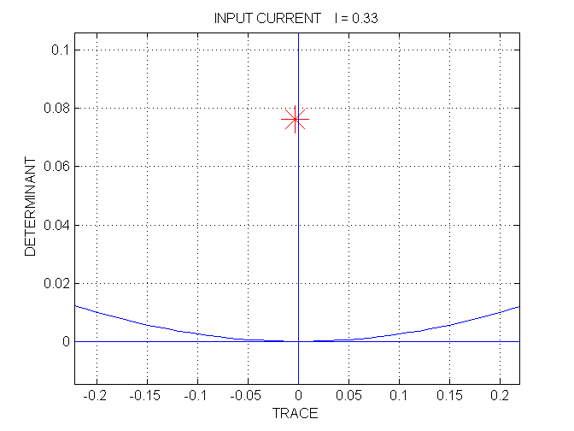
The equilibrium point is still a stable spiral, but the TD point is very close to the vertical axis (i.e., the trace is negative but very close to 0). There is an unstable limit cycle of small amplitude, between the two trajectories shown. The outer trajectory converges to the large stable limit cycle (only a small portion of which is seen in the phase portrait at the scale shown).
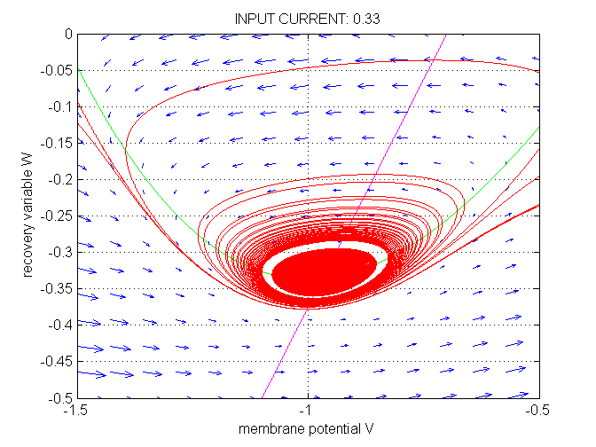
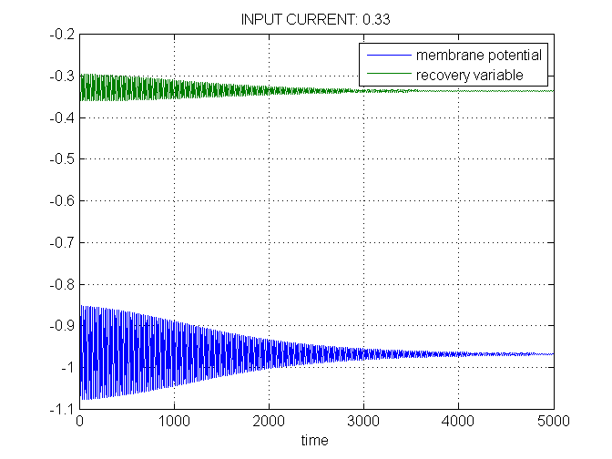
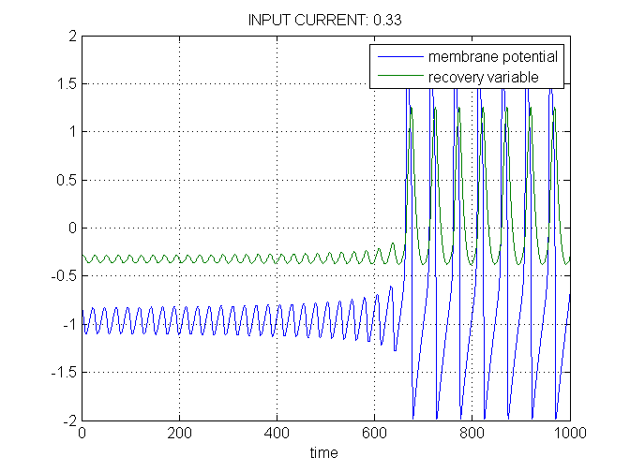
Observations for Input = .35:

The equilibrium has become unstable, and the small unstable limit cycle has disappeared. All trajectories (other than the equilibirium) converge to the large stable limit cycle.
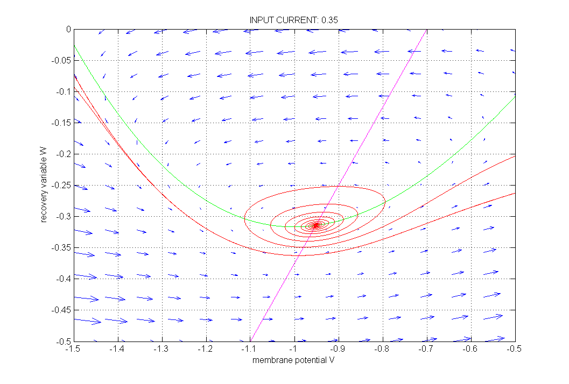
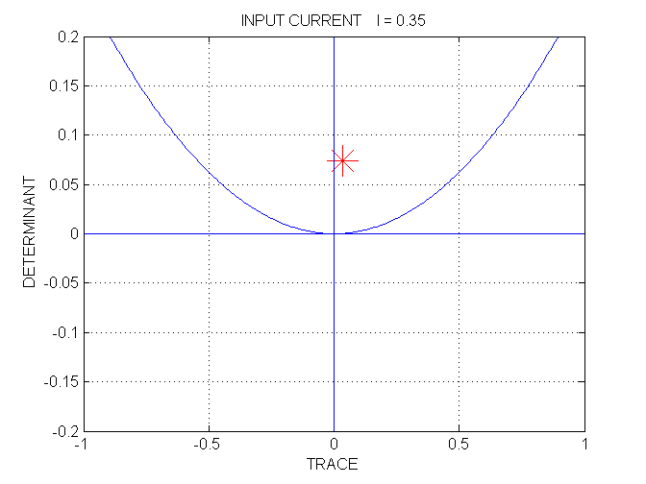

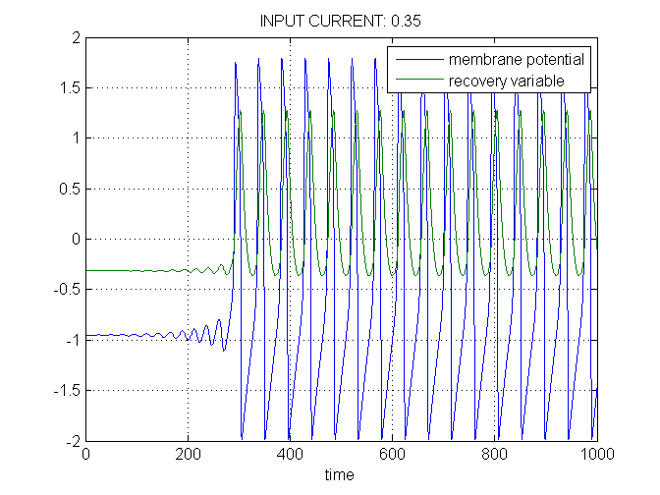

SUMMARY. The bifurcation observed here is called a subcritical Hopf bifurcation: when the bifurcation parameter (Input) is lowered from 0.35 to 0.33, a small unstable limit cycle bifurcates away from the unstable spiral equilibrium, which becomes stable. (A supercritical Hopf bifurcation is one where a small stable limit cycle bifurcates away from a stable spiral equilibrium, which becomes unstable.)

