The Saddle-Node Bifurcation

Consider the autonomous system of differential equations

$\begin{matrix}\frac{dx}{dt}=x^{2}-μ \\ \frac{dy}{dt}=-y\end{matrix}$

where μ is a parameter.

If μ > 0:

There are two equilibria: (–√μ , 0) and (√μ , 0).

The Jacobian at (–√μ, 0) is: $\left[\begin{matrix}-2\sqrt{μ} & 0 \\ 0 & -1\end{matrix}\right]$ .

Thus, T = – 2√μ –1 and D = 2√μ, yielding T²/4 – D = (2√μ – 1)²/4 > 0. Hence (–√μ, 0) is a stable node.

The Jacobian at (√μ, 0) is: $\left[\begin{matrix}2\sqrt{μ} & 0 \\ 0 & -1\end{matrix}\right]$ .
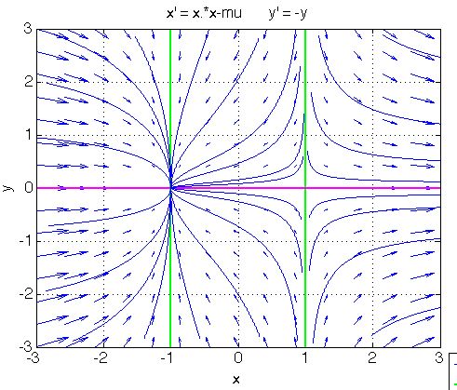
Thus, T = 2√μ –1 and D = – 2√μ. Hence (√μ, 0) is a saddle point.

To the left is the phase portrait obtained for μ = 1, showing the two equilibria:

attracting node at (–1, 0),

saddle point at (1, 0).

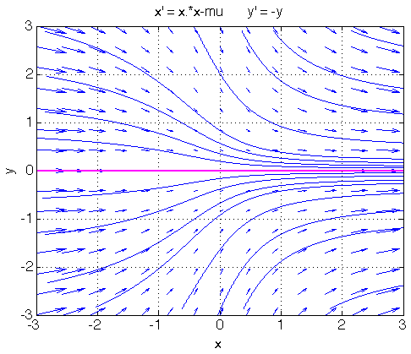

If μ < 0:

There is no equilibrium.

To the left is the phase portrait obtained for μ = –1.

Conclusion:

A bifurcation takes place at μ = 0. This type of bifurcation, where two equilibria, a stable node and a saddle point, disappear by merging with each other is called a saddle-node bifurcation.

This type of bifurcation occurs in the excitatory-inhibitory network which we shall study next.

