Covariances and related notions

I. Covariance between two r.v.'s
Remember that the variance of a r.v. X is:
var(X ) = E[(X – μ _{X})²] = E[(X – μ _{X}) × (X – μ _{X})] = E[X ²] – μ _{X}².
Now the covariance of two r.v.'s X and Y (defined on a common probability space Ω) is:
cov(X, Y ) = E[(X – μ _{X}) × (Y – μ _{Y})].
So we see that:
var(X ) = cov(X, X ).
If the two r.v.'s X and Y are independent, then cov(X, Y ) = 0. Thus, computing the covariance of X and Y provides a partial answer to the question: are X and Y independent? This is only a partial answer, because cov(X, Y ) = 0 does not imply that X and Y are independent.
It is easy to see that:
cov(X, Y ) = E[X × Y ] – μ _{X} ×μ _{Y}.
Thus, the covariance is the mean of the product minus the product of the means. Instead of the covariance, one sometimes uses the correlation, which is simply the mean of the product:
corr(X, Y ) = E[X × Y ].

II. Cross-correlation between two time series
Consider now two time series X (t) and Y(t). A time series is a random variable that is a function of time t, t = 1, 2,…
Here we assume that X (t) and Y(t) are spike trains, and therefore X (t) and Y(t) ∈{0, 1}.
The cross-correlation between X (t) and Y(t), a function of the time variable τ, is defined as:
crosscorr_{X, Y} (τ ) = corr(X(t), Y(t+τ)) = E[X(t) × Y(t+τ)].
The variable τ should be understood as a time lag: for a given time lag τ, crosscorr_{X, Y} (τ ) is large if a spike in Y often occurs at time t + τ whenever a spike in X occurred at time t.
Note that the definition of the cross-correlation assumes that E[X(t) × Y(t+τ)] does not depend on t. This property is called stationarity.
It is easy to see that, up to a normalization constant, crosscorr_{X, Y} (τ ) is the conditional probability that the second neuron will fire at time τ, given that the first neuron fired at time 0.

III. Autocorrelation of a time series
The autocorrelation of a single spike train X (t), also a function of time τ, is defined as:
autocorr_{X} (τ ) = corr(X(t), X(t+τ)) = E[X(t) × X(t+τ)].
We see that the autocorrelation of spike train X (t) is the cross-correlation of X (t) with itself: autocorr_{X} (τ ) = crosscorr_{X, X} (τ ). Thus, autocorr_{X} (τ ) is large if, in X (t), a spike at a given time t is often followed by a spike at time t+τ. Note that if the neuron has a refractory period, say of 5 ms, then, for any τ less than 5ms, autocorr_{X} (τ ) will be small, or even 0.

IV Correlograms
To each of the above notions, there corresponds a formula that allows one to estimate the quantity from a sample. Thus, given a sampled spike train x(t), t = 1,2,…, the sample autocorrelation, or autocorrelation histogram, or autocorrelogram of the spike train, is:
autocorr_{X} (τ ) = ,
where N is the length of the recording period. Remembering that x(t) is a spike train, hence x(t)∈{0, 1}, we can write:
autocorr_{X} (τ ) = ,
where T_{i} runs over all spike times.
Practically, to compute the autocorrelogram for lags τ in a given interval [–τ_{max}, τ _{max}], one adds up with each other all the segments of spike train extracted from the intervals [T_{i} –τ_{max}, T_{i} +τ _{max}]. This operation is illustrated below:
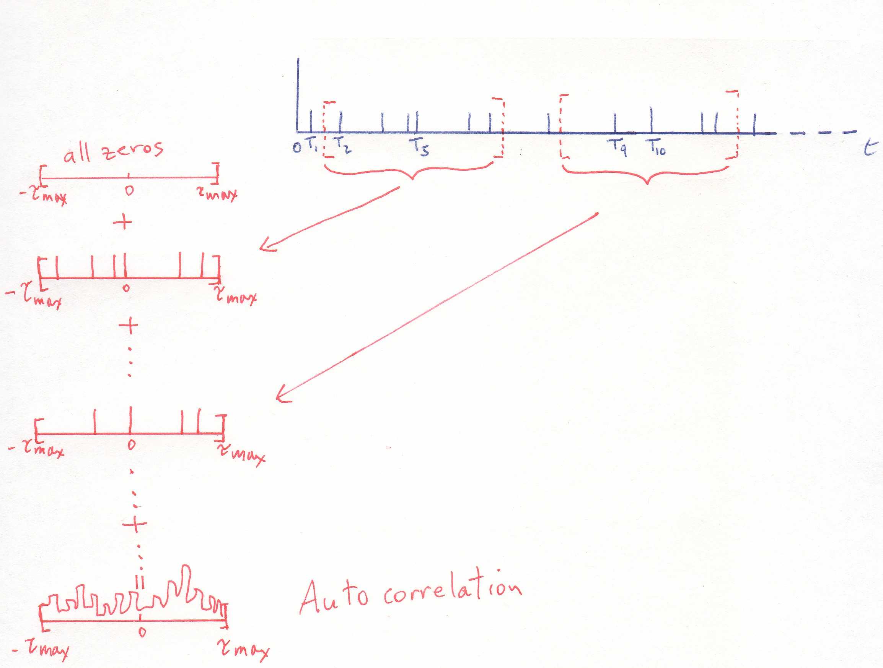

In this sum, T_{i} runs over all the spike times in the record. This will often result in some extracted segments overlapping with each other, such as, for instance, the segments around T₉ and T₁₀ in the above sketch (the segment around T₉ is not shown). This is not a problem.
However, notice that if some T_{i} (for instance T₁ or T₂ in the above sketch) is very near the beginning or the end of the record, the extracted segment may not fall entirely within the recording period, and this would cause a problem. Therefore, one should use only "legitimate" T_{i}'s, i.e., spike times T_{i} such that the interval [T_{i} –τ_{max}, T_{i} +τ _{max}] is entirely within the recording period [1, N].
The cross-correlogram between a spike train x(t) and a spike train y(t) is computed in exactly the same way, except that now the T_{i}'s come from one spike train x(t), whereas the spike-train segments are extracted from another spike train y(t). This is sketched out below:

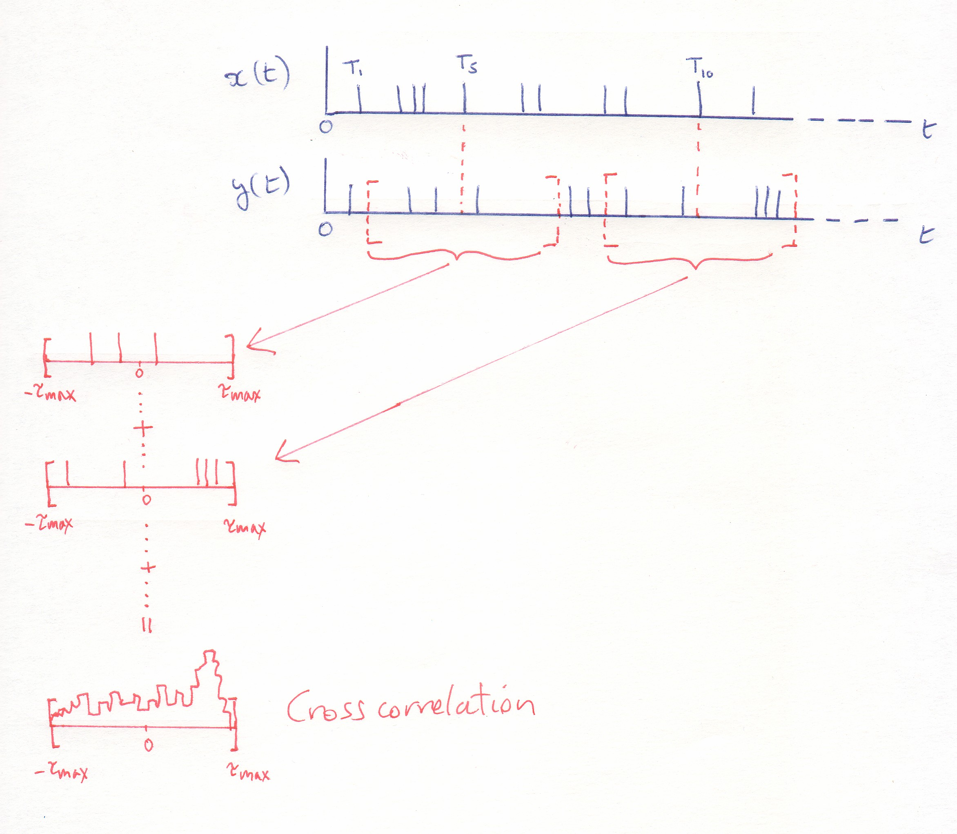
V. Examples of autocorrelograms and crosscorrelograms in the neuroscience literature
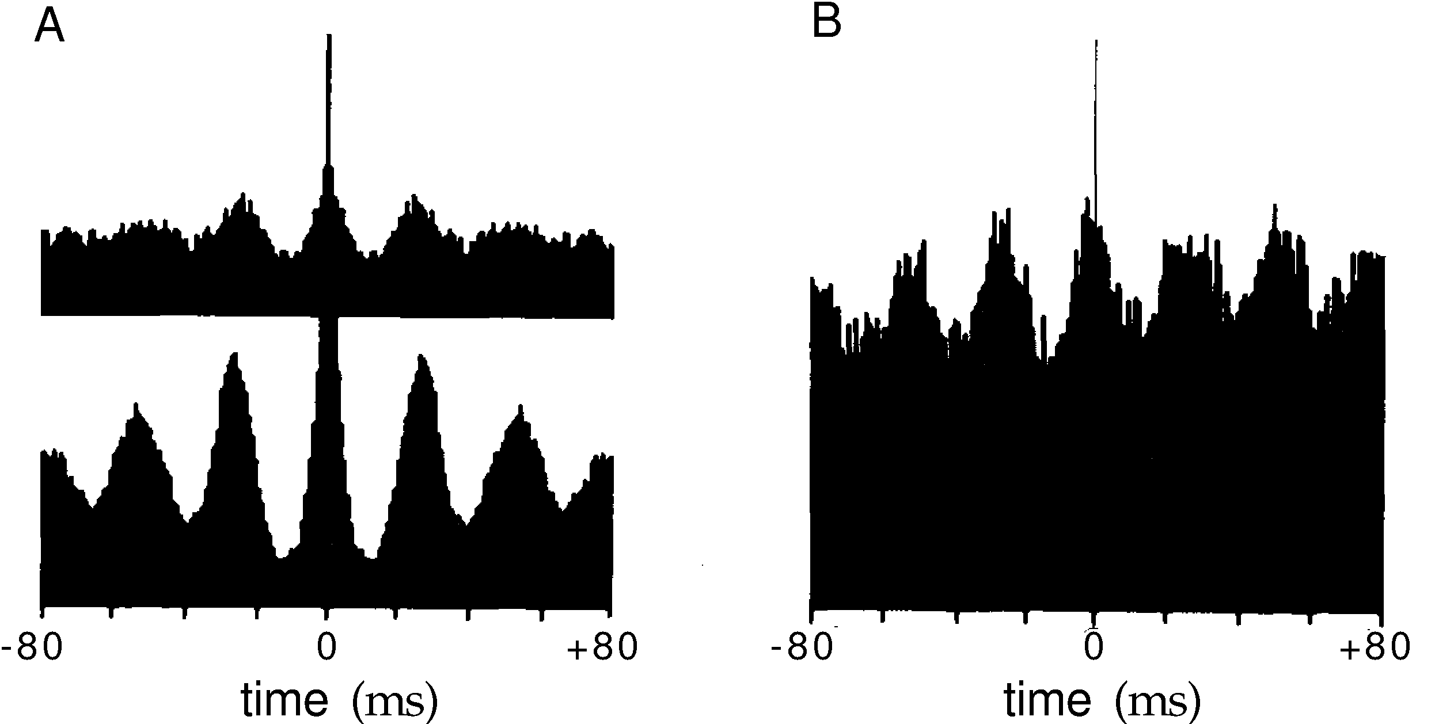
A: Autocorrelograms for two neurons in right and left hemispheres of areas V1 of the cat. B: Crosscorrelograms for same two neurons. (From Engel, König, Singer (1991) Direct physiological evidence for scene segmentation by temporal coding, PNAS 88:9136-9140)

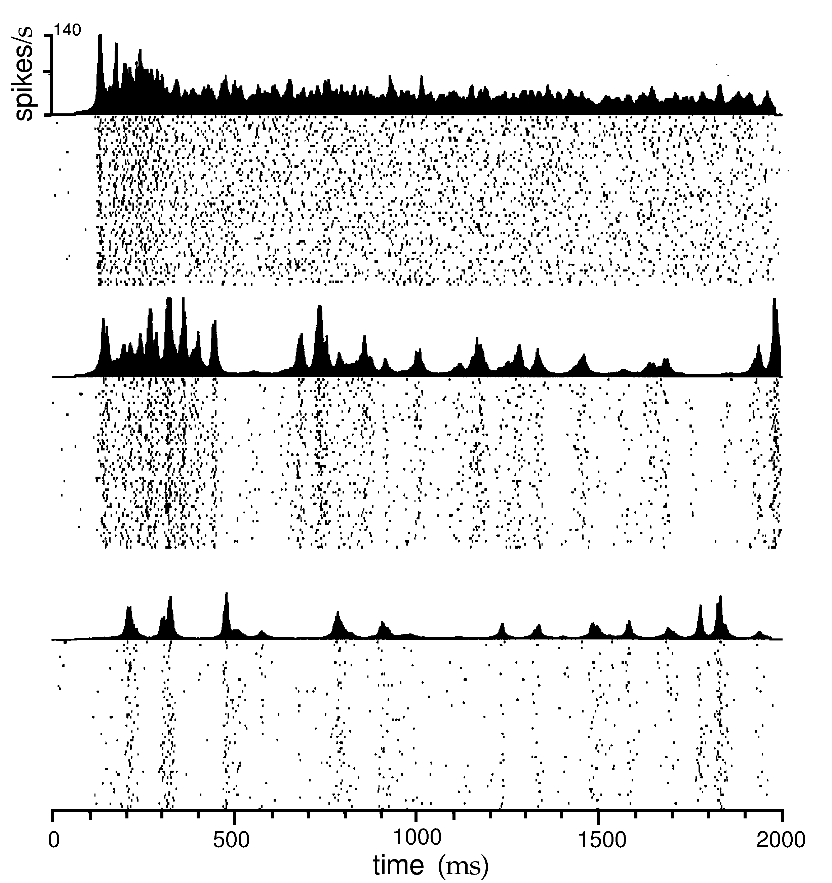
Raster plots and histograms (post-stimulus-time histograms, or PSTH's) of response of MT neuron to patterns of moving random dots. The three panels (top to bottom) show the responses to stimuli of increasing "coherence." (From Bair and Koch (2006) Temporal coherence of spike trains in extrastriate cortex of the behaving macaque monkey, Neural Computation, 8:1185-1202.)

Note that a post-stimulus-time histogram, or PSTH, for a given neuron's response to a given stimulus is the cross-correlogram of two time series: the spike train and the time series that marks the stimulus onset times.

