**Excitatory-Inhibitory Neural Network**

Consider the system:



where *a* is a positive parameter.

This system of autonomous first-order differential equations is a simplified model of the mean activities of a population of interacting excitatory (*x*) and inhibitory (*y*) neurons. (See: “Regulated Criticality in the Brain?”, Elie Bienenstock and Daniel Lehmann, 1999,

*Advances in Complex Systems*, 1, pp 361-384, [pdf](http://www.dam.brown.edu/people/elie/papers/regulation.ps))

The *hyperbolic tangent* function tanh(*x*) is defined as follows:

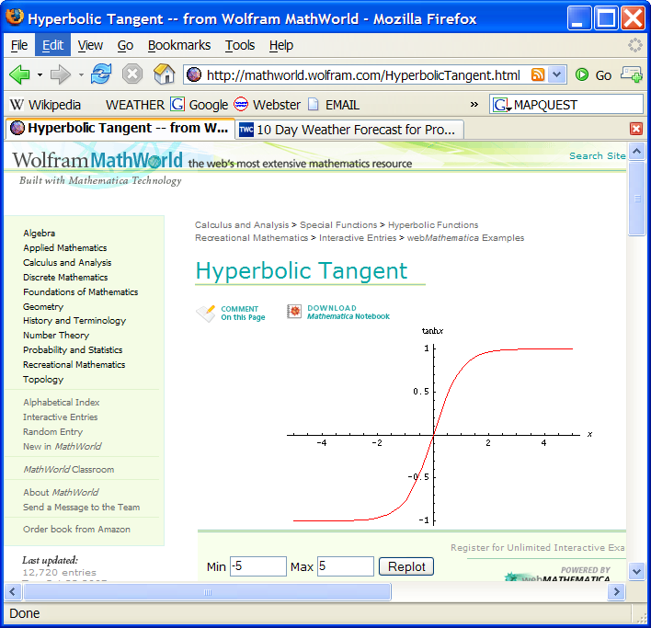

$$\tanh\left(x\right)=\frac{e^{x}-e^{-x}}{e^{x}+e^{-x}}=\frac{1-e^{-2x}}{1+e^{-2x}}$$

This function tanh(*x*) is defined for all real values of *x*, and it increases smoothly from –1 to 1 as *x* goes from – ∞ to + ∞. It has a *sigmoid* shape. Note that the function is built-in in Matlab, and it is conveniently called tanh. The derivative of tanh(*x*) is:



where cosh(*x*) is the *hyperbolic cosine* function, defined as follows:

cosh(*x*) = ( exp(*x*) + exp(–*x*) ) / 2.

The region of interest for this dynamical system is:

*R* = {(*x*,*y*) : –0.5 ≤ *x* ≤ 0.5 and –0.5 ≤ *y* ≤ 0.5}.

It is fairly easy to see that any trajectory that starts within *R* remains within *R*. This is one of the conditions for region *R* to be used in the Poincaré-Bendixson theorem.

The Jacobian matrix is easily derived:



The origin is an equilibrium point for all values of *a*.

Since *cosh* (0) = 1, we see that the Jacobian at the origin is:



yielding *T* = *a*/2 – 3 and *D* = 22 – *a*.

We remark that parameter *a* affects only the V-nullcline.

Finally, before we turn to the numerical study, we note that the entire system is symmetric around the origin. Indeed, if we replace *x* by – *x* and *y* by – *y*, *x'* becomes –*x'* and *y'*  becomes –*y'*. This is because tanh (–*x*) = – tanh (*x*).

**Parameter setting:** *a* = 2

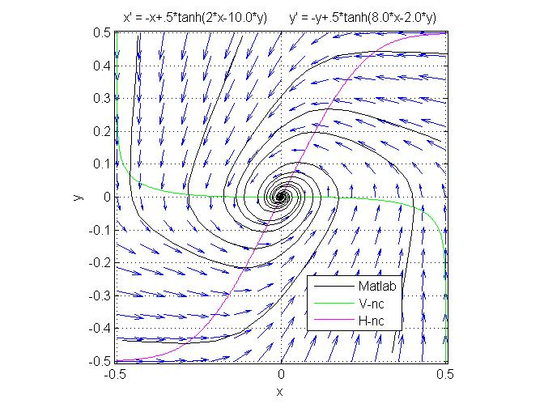

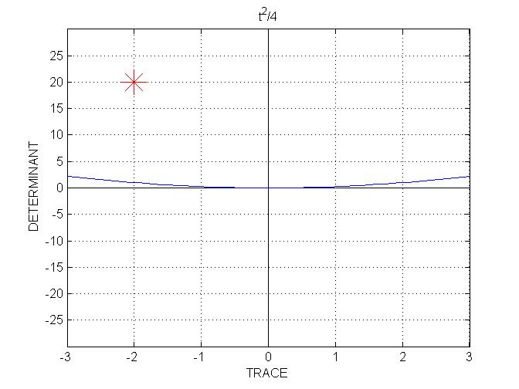

Clearly, the origin is the only equilibrium.

The trace of the Jacobian is *T* = – 2 and its determinant is *D* = 20. This places the system well within the stable-spiral region.

**Parameter setting:** *a* = 7.

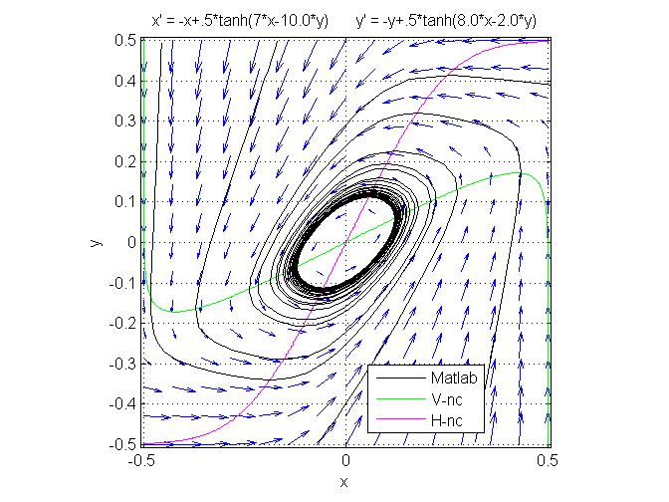

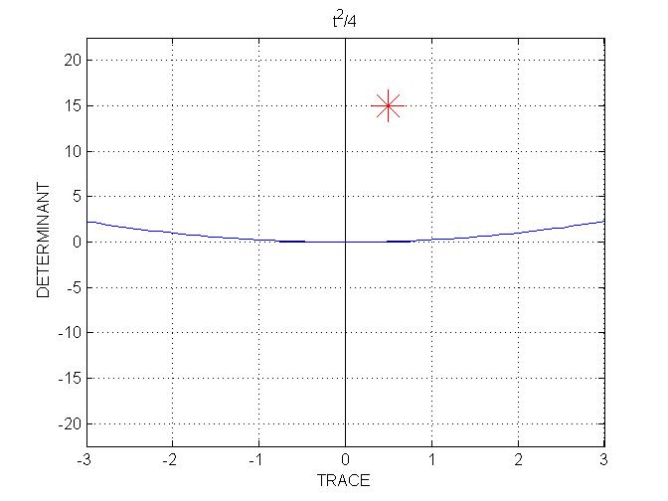

The origin is still the only equilibrium.

The trajectories seem to converge to a limit cycle. In order to confirm this, we note that now *T* = 0.5 and *D* = 15. This places the behavior at the origin within the unstable spiral region. Since the origin is the only equilibrium within *R* and it is unstable, all the conditions of the Poincaré-Bendixson theorem are met, hence there must be a periodic attractor in *R*.

As we increased parameter *a* from 2 to 7, the equilibrium at the origin went from a stable spiral to an unstable spiral, since we crossed the vertical line *T* = 0 in the *T-D*  plane. The bifurcation takes place at *a* = 6, since this is the value of *a* that gives *T* = 0. This bifurcation is of the **supercritical** **Hopf** type.

Let us examine what happens when parameter *a* is just a little larger than the bifurcation value 6:

**Parameter setting:** *a* = 6.1

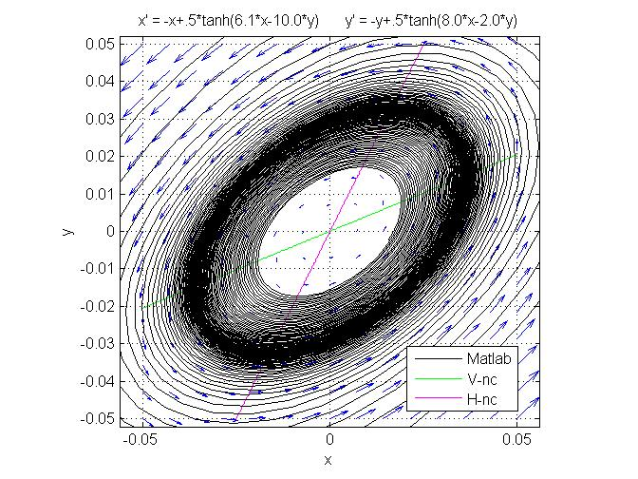

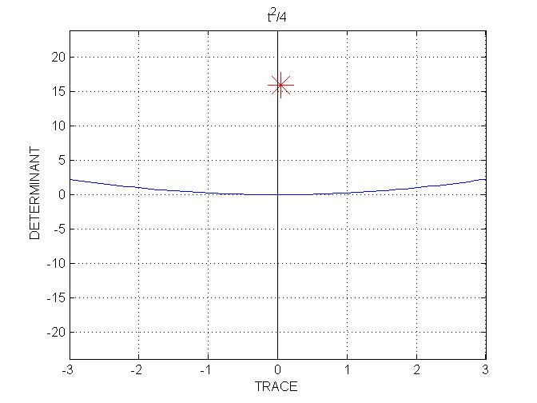

The phase portrait shows two trajectories in a small region around the unstable equilibrium (note the scale on the *x* and *y* axes).

We see that there is a limit cycle of elliptic shape. This is indicated by the dark region, where the trajectories become denser as they approach the cycle. One of the two trajectories shown is inside the cycle, and the other is outside. The cycle is near the middle of the dark region.

This limit cycle is of small amplitude, as it should be at a supercritical Hopf bifurcation.

Let us now further increase parameter *a*:

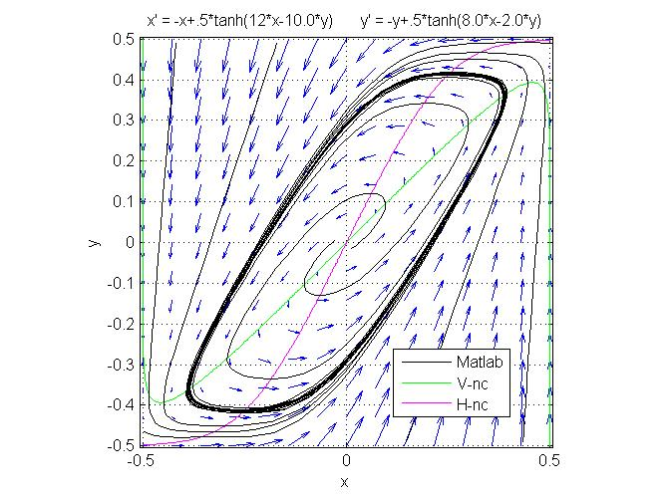**Parameter setting:** *a* = 12.

The origin still is the only equilibrium.

The trace and determinant of the Jacobian at the origin are: *T* = 3 and *D* = 10. We still are well within the unstable spiral region.

The Poincaré-Bendixson theorem still applies, and there still is a limit cycle.

The limit cycle is now larger, and more rectangular in shape.

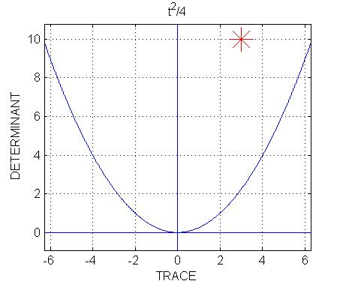We note that, by gradually increasing parameter *a*, we increased the slope of the V-nullcline.

Given the shape of the H-nullcline, which remains fixed when *a* increases, we should expect that if we further increase parameter *a* the two nullclines will eventually intersect each other near the top-right and bottom-left corners of the square.

This situation is examined next.

**Parameter setting:** *a* = 15.

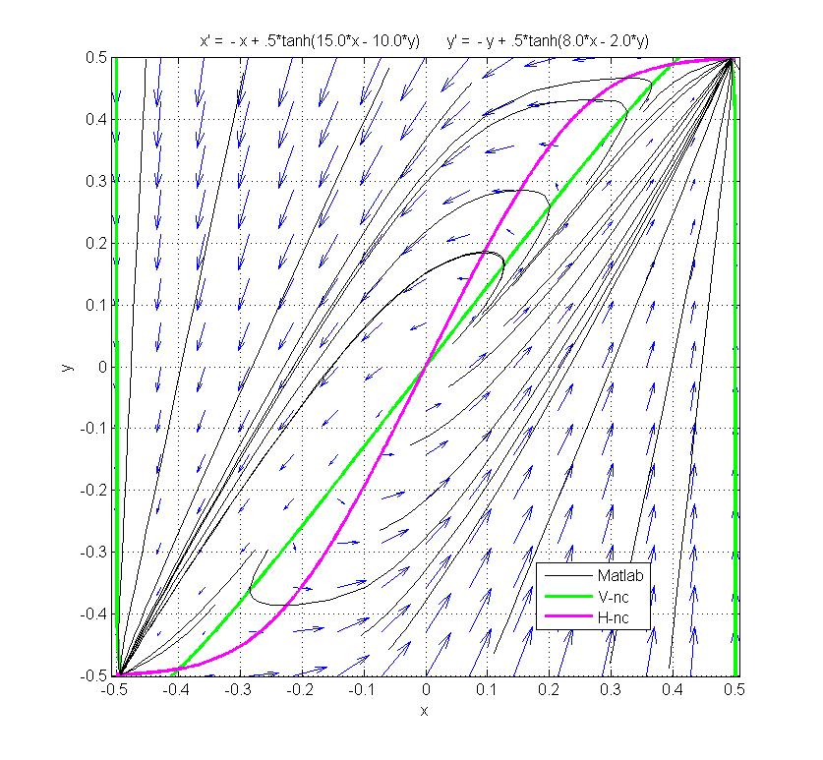

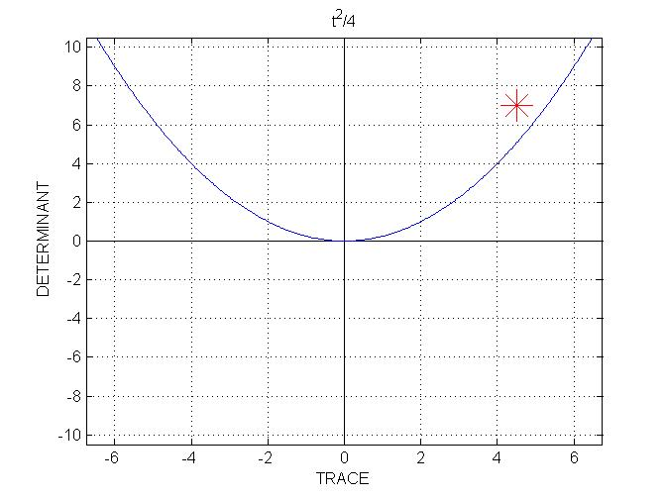

The slope of the V-nullcline is large enough that the two nullclines intersect near the corners.

As a result, there are now 5 equilibrium points.

The trace and determinant of the Jacobian at the origin are: *T* = 4.5 and *D* = 7. The origin is still within the unstable-spiral region.

There are two intersection points near the upper right corner. Since the system is exactly symmetric, there also are two intersection points near the bottom left corner.

We see that only one in each pair of equilibria, the one closest to the corner, is stable.

Thus, out of the 5 equilibria in *R*, two are stable. Hence the Poincaré-Bendixson theorem does not predict the existence of a limit cycle.

Indeed there is no limit cycle in this case. Instead, the two stable equilibria, near the corners of *R*, attract all the points in *R* (except unstable equilibria and points on separatrices).

To elucidate the nature of the stable and unstable equilibria, we examine the phase 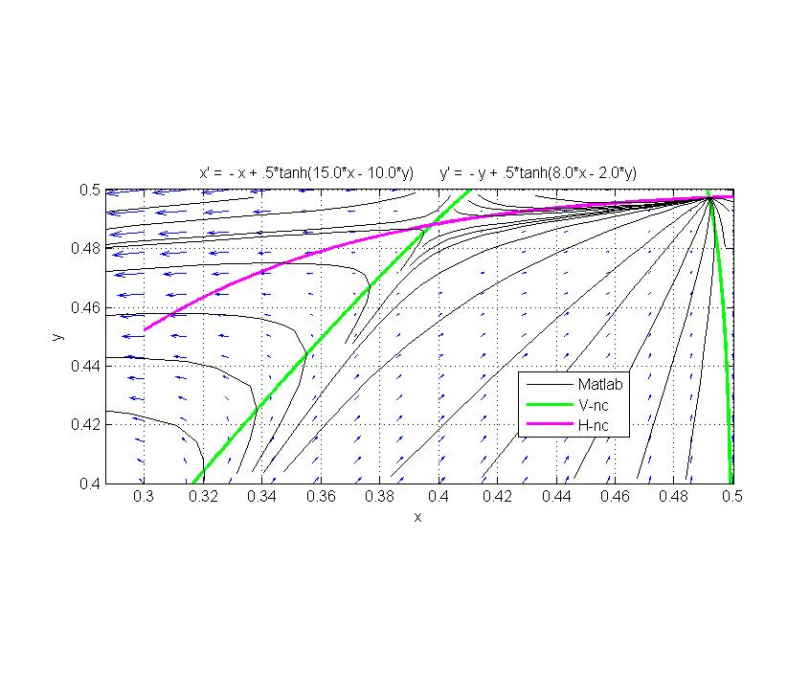portrait in the upper right corner at higher resolution:

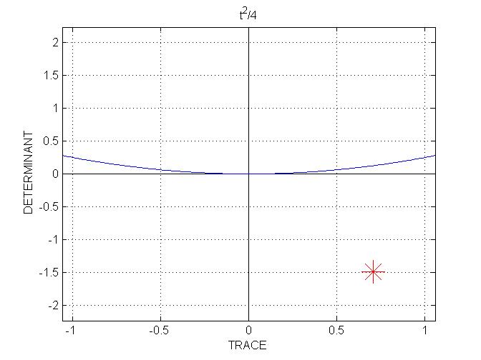

From inspection of the phase portrait, the unstable equilibrium seems to be of **saddle**-**point** type, and this is is confirmed by the T-D analysis.

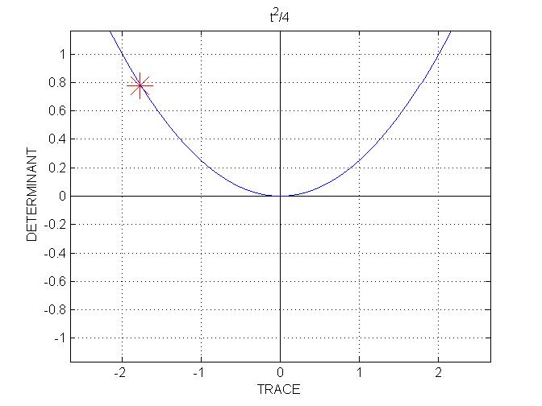The stable equilibrium seems to be of **node** type.

The T-D analysis indicates a star node, but we can't know for sure. The (*T*, *D*) point could actually be slightly to the left of the parabola, in which case we have a regular node; or it could be slightly to the right of the parabola, giving a spiral point. This cannot be determined analytically, because the position of the equilibrium is known only approximately, from the nullcline plot. But it is a purely theoretical issue. In practice, the spiraling around the attractor, if present, is too tenuous to be seen. The main point is that the equilibrium is well within the region of stability.

Using a trial-and error method, one can find that the bifurcation value for *a* is, approximately, 14.22.

The following shows what happens just **before** the bifurcation.

**Parameter setting:** *a* = 14.215.

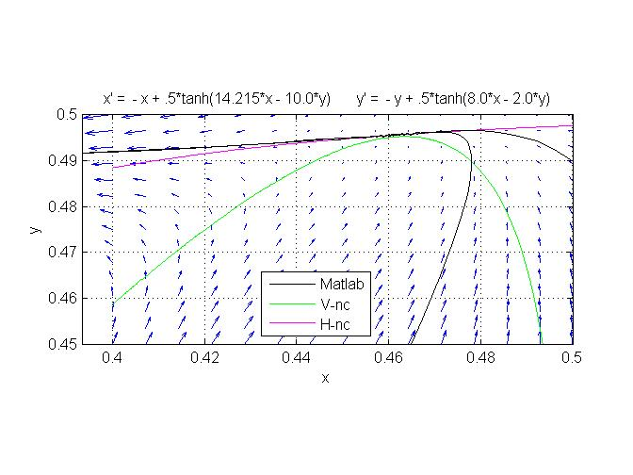

For this value of *a*, the nullclines are almost touching, but not quite. As a result, there still is a limit cycle, and this is the only attractor in *R*. The above diagram is a blow-up of the upper-right corner, showing a *single trajectory*. This trajectory starts at (0.5, 0.49), passes very close to the point of almost contact of the nullclines, where motion slows down considerably, and then effects a large loop before coming again from below, being then indistinguishable from the very large limit cycle.

The following shows what happens just **after** the bifurcation.

**Parameter setting:** *a* = 14.225.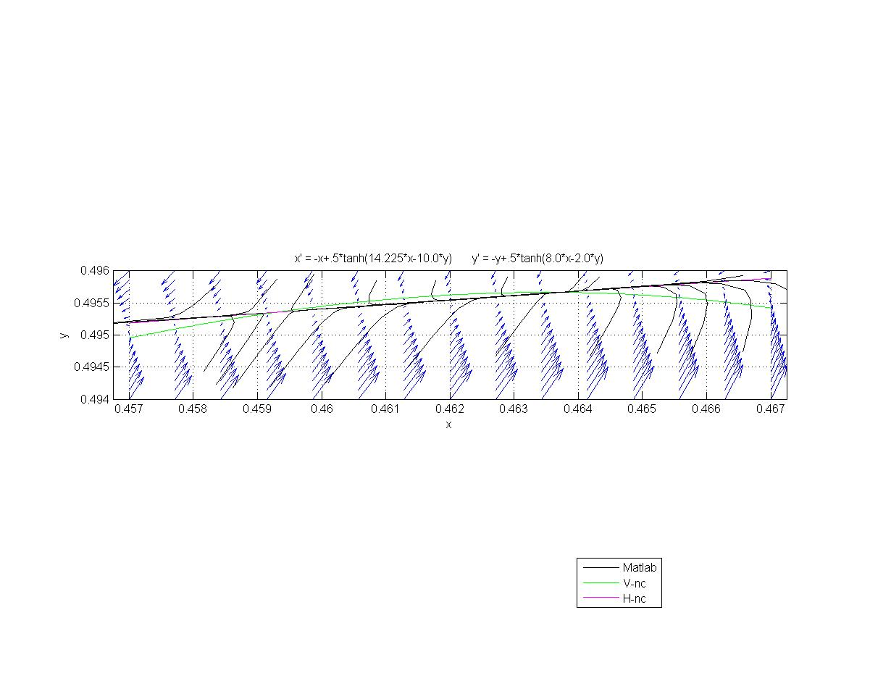

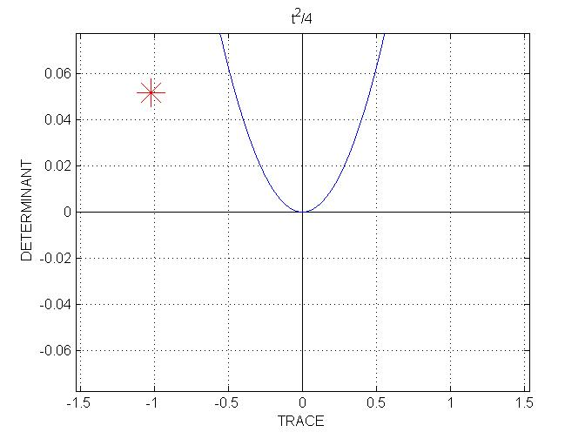

The stable equilibrium, which, from examining the nullcline diagram, is approximately (0.4636, 0.4957), is a node.

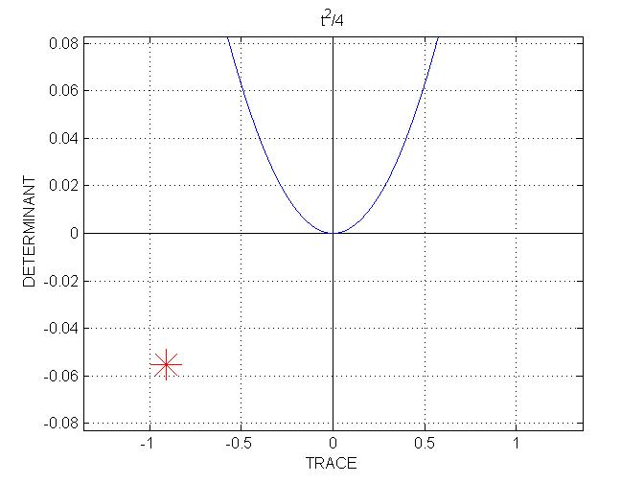

The unstable equilibrium, which is approximately (0.4593, 0.4954), is a saddle point.

We see that these two equilibria, the node and the saddle point, are quite close to the line *D* = 0 in the (*T*, *D*) plane, and are located, roughly, symmetrically with respect to this line.

We conclude that this bifurcation is of **saddle-node** type.

**Concluding remarks**

This rather simple system of two coupled first-order autonomous differential equations exhibits a variety of behaviors, depending on parameter values.

The three main behaviors are:

1. Single point attractor in the center of *R*. This corresponds to an intermediate level of steady-state activity for both neuron populations, excitatory and inhibitory.
2. One point attractor near the top-right corner of *R* and one point attractor near the bottom-left corner. These point attractors correspond, respectively, to a state of high-activity for both populations of neurons and to a state of low-activity for both populations.
3. One large counterclockwise limit cycle, correponding to strong periodic oscillation of the two populations, the excitatory population leading.

Of interest are the bifurcation points of the system. When the system is close to a bifurcation, a **small** **perturbation** may cause the system to **switch** from one type of behavior to a very different type of behavior.

A perturbation can be either a small change in the parameters (as demonstrated in the study), or it can be brought about by an external input of small amplitude, which can be modeled as a non-autonomous term (not shown in this study).

In particular, when the system is close to the saddle-node bifurcation, a small perturbation may cause a dramatic change of behavior.

Might there bemechanisms in the central nervous system that would systematically bring the parameters close to bifurcation? Such mechanisms could be of value to the brain, as they might allow it to be exquisitely sensitive to small changes in the environment.

Such mechanisms have indeed been proposed. See [Regulated Criticality in the Brain?](http://www.dam.brown.edu/people/elie/papers/regulation.ps) for such a mechanism related to Hebbian plasticity and based on the system studied here.